World History 3201 - Unit 05-06

5.1 Students will be expected to draw upon primary and/or secondary sources to demonstrate an understanding of the challenges of nationalism and independence movements after World War II - spotlight India, Egypt, and South Africa.

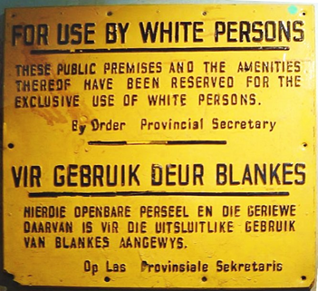
•5.1.1 Define:
◦self-determination, the free choice of a people to choose their own political future ie. to choose their own form of government. It was a concept jointly endorsed by Franklin D. Roosevelt and Winston Churchill when they signed the Atlantic Charter in August 1941 in Placentia Bay. The Charter outlined eight principles regarding the goals of Britain and the United States in WWII.
The main ones were: 1. no territorial gains were to be sought by the United States or the United Kingdom, 2.territorial adjustments must be in accord with the wishes of the peoples concerned; 3.all people had a right to self-determination (the right to choose their own government.)
◦colonialism, the economic, political and cultural domination by one country over another country or group of people.
◦Indian Independence Act, 1947 Act that divided India and Pakistan and also gave them independence.
◦apartheid, 1948 South African racial policy that divided South Africans into white and non-white. The policy resulted in racial segregation, restrictions on marriages, residences, and education.
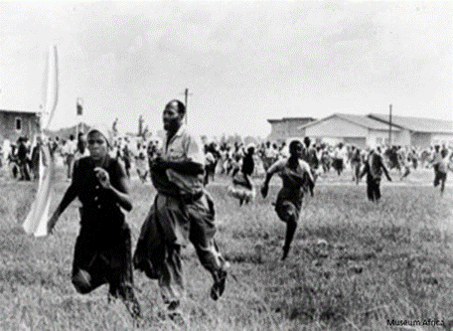
◦African National Congress nationalist group that used non-violent resistance to attack racial discrimination in South Africa. They used boycotts, strikes, demonstrations, and openly defied segregation laws by entering “whites” only areas and facilities.

•5.1.2 Identify on a map the major colonial powers in the immediate years after World War II.
The major colonial powers post WWII were Great Britain (UK), France, and the Soviet Union (USSR).
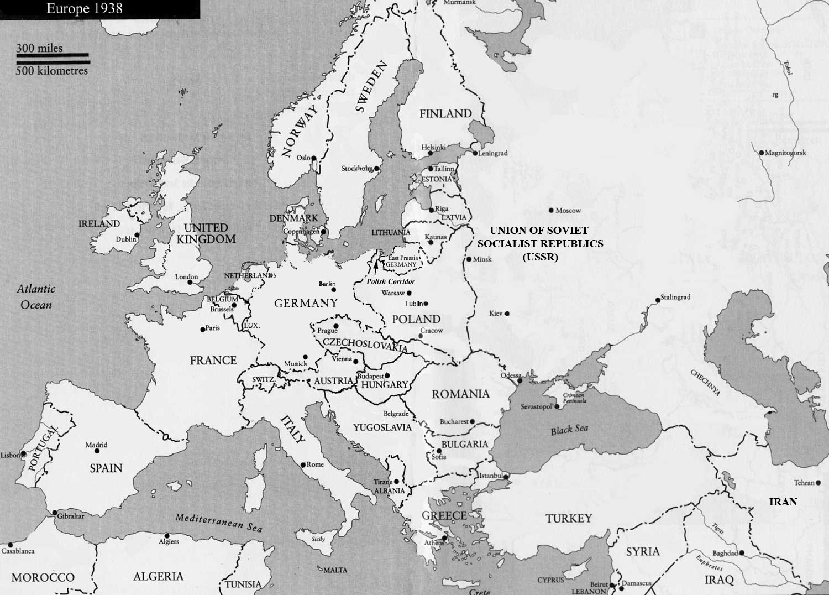

•5.1.3 Given historical documents, explain the cause of the Suez Crisis.
Background to the Suez Crisis: Gamal Nasser emerged as the leader of Egypt following the Arab-Israeli of 1948. His two main goals were to:
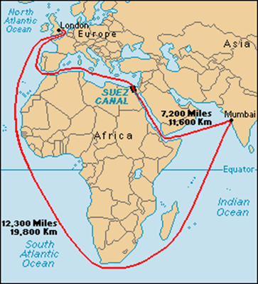
1. create an independent Egypt free from colonial rule
2. destroy the newly formed nation of Israel.

Nasser who held no preference for either communism or democracy was willing to accept American or Soviet aid. To achieve his goals Nasser was willing let the superpowers bid for his allegiance.Nasser needed a modern army to destroy Israel and in 1955 he signed an arms deal with Czechoslovakia a Soviet bloc nation.
To develop Egypt economically and end colonial power he needed electricity. In 1956 he signed a deal with the U.S. to help build the Aswan Dam power project. Nasser’s balancing act of getting aid from both sides was about to crumble.
The Suez Crisis 1956: Nasser began to lose Western support due to America’s concern over Nasser’s non-aligned nationalism and Egypt’s continuing conflict with Israel which had close ties to the U.S. Contrary to international and UN agreements Egypt stopped all Israeli ships and all ships bound for Israel from using the Suez Canal. The U.S. then refused financial aid for the Aswan Dam. Nasser reacted immediately by seizing control of the Suez Canal and turned to the Soviets for help in building the Dam. Egypt’s takeover of the Canal was peaceful; Britain and France the owners were offered market value and full use of the Canal. Nevertheless this event increased global tensions. Britain and France devised a scheme to regain control of the Canal. Israel was to attack Egypt as part of the ongoing Arab-Israeli dispute. Britain and France would land troops at the canal zone on the pretence to protect international shipping. Once here they would take control of the canal, Israel would expand its territory and Nasser would be overthrown. The conspirators miscalculated world reaction.
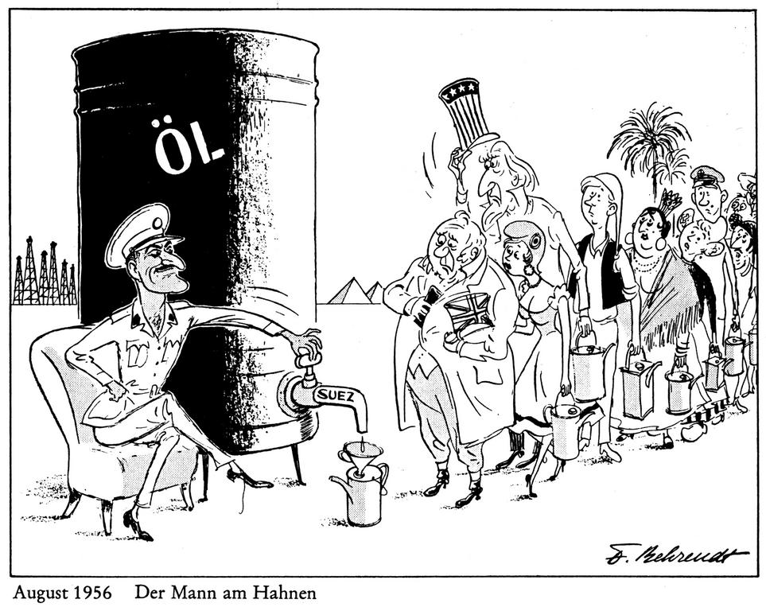
Results of the Suez Crisis: The Soviets threatened to launch missiles on Paris and London. The United States was outraged with France and Britain. The U.S. introduced a motion at the UN calling for Israel to withdraw its troops and for all members to refrain from the use of force. France and Britain vetoed this motion as well as a Soviet motion that the Soviets and Americans jointly intervene. The Security Council finally suggested that the matter go before the General Assembly which could not be vetoed. (Procedural) On Nov. 2 an American resolution called for a cease fire and international action to ensure the passage through the Suez Canal. On Nov.4 Canada’s UN representative, Lester Person, proposed the British & French force in the Canal zone be replaced by a peacekeeping force. The lasting significance of the Suez Crisis was the creation of UN peacekeeping forces.

Once on an exam they showed a cartoon of Nasser tearing up the Suez Canal Treaty. The question asked to explain how Nasser's actions caused the Suez Crisis. here's a decent answer to that question....
In 1956, at the height of the Cold War, the world came very close to nuclear war as the result of a conflict between Britain and France on one side and Egypt on the other, over the Suez Canal in Egypt. The Suez Canal was a waterway that connected the Red Sea to the Mediterranean Sea. It had been built and was owned by Britain and France. It was located in Egypt which had been a British colony. In 1952 a man by the name of Nasser overthrew the king of Egypt and set up the new independent Republic of Egypt. Nasser had two main goals: to make Egypt strong and independent and also to destroy the newly created state of Israel. He began by asking both Britain and the U.S. for military aid, and financing for a hydro-electric dam that he wanted to build – the Aswan Dam. They refused him the military aid, but the U.S. did offer him money to build his dam. Nasser then turned to Soviet Union instead for military aid and worked out a deal whereby he would receive arms from Czechoslovakia. When the U.S. found out about this deal they withdrew their offer of money to finance the Aswan dam. A frustrated Nasser then decided to nationalize the Suez Canal. This means that he made the dam the property of Egypt and sent the British and the French workers home. Britain and France were obviously upset, and ending up working out a secret deal with Israel whereby Israel would attack Egypt and they would have to intervene to save the dam. In the process, Britain and France would get the dam back. They went ahead with their plan and the world was outraged. The U.S. was upset with Britain and France, the U.S.S.R. threatened to launch missiles on London and Paris. The U.S. said they would defend their allies. It was a very tense time and almost came to nuclear war. It might have done too, had not the Canadian representative at the United Nations, Lester Pearson, stepped in and suggested a solution that ended the crisis. In the source we see a cartoon of President Nasser of Egypt, he seems to be tearing up the Suez Canal Treaty which represents when he nationalized the canal. The cartoon also portrays his anti-west speeches and his policy of not allowing Israel to use the Suez Canal.

•5.1.4 Analyze how the following factors led to the decline of colonialism (decolonization) in the post-World War II period:

The end of WWII signalled the decline and eventual end of the European colonial empires. Nationalism spread throughout colonies and eventually one by one they gained independence. A variety of factors led to the decline of colonialism.

◦Premises of the Atlantic Charter: The Atlantic Charter (1941) promoted sovereignty and self-government for all nations. This encouraged nationalists in colonies to fight for independence. Colonial nationalist movements grew in the colonies. Ironically the leaders of these groups were trained in Western ideas at universities such as France, Britain and other Western countries. These people returned home to emerge as the leaders of nationalist groups that fought for independence.

◦Colonial nationalist movements: Many former colonies took pride in their contributions to the war effort. The pride gave them the confidence they needed form nationalist movements. Movements that envisioned themselves as independent nations rather than colonial underlings of European powers.

◦Cost of maintaining colonies: Many European countries supported independence in colonies because of the high cost of maintaining them. European powers were unable to justify holding these colonies when there economies were struggling following 6 years of war.

◦views towards colonialism by the United States and Soviet Union: Following WWII both the U.S. and Soviet Union wanted to see the breakup of the European empires. The U.S. having waged a war of independence against Britain (1776) supported independence movements. The U.S. also felt if Europe lost its empires they would have greater access to colonial markets. The Soviets opposed European empires feeling that if the empires collapsed there would be greater opportunities for establishing communist countries.
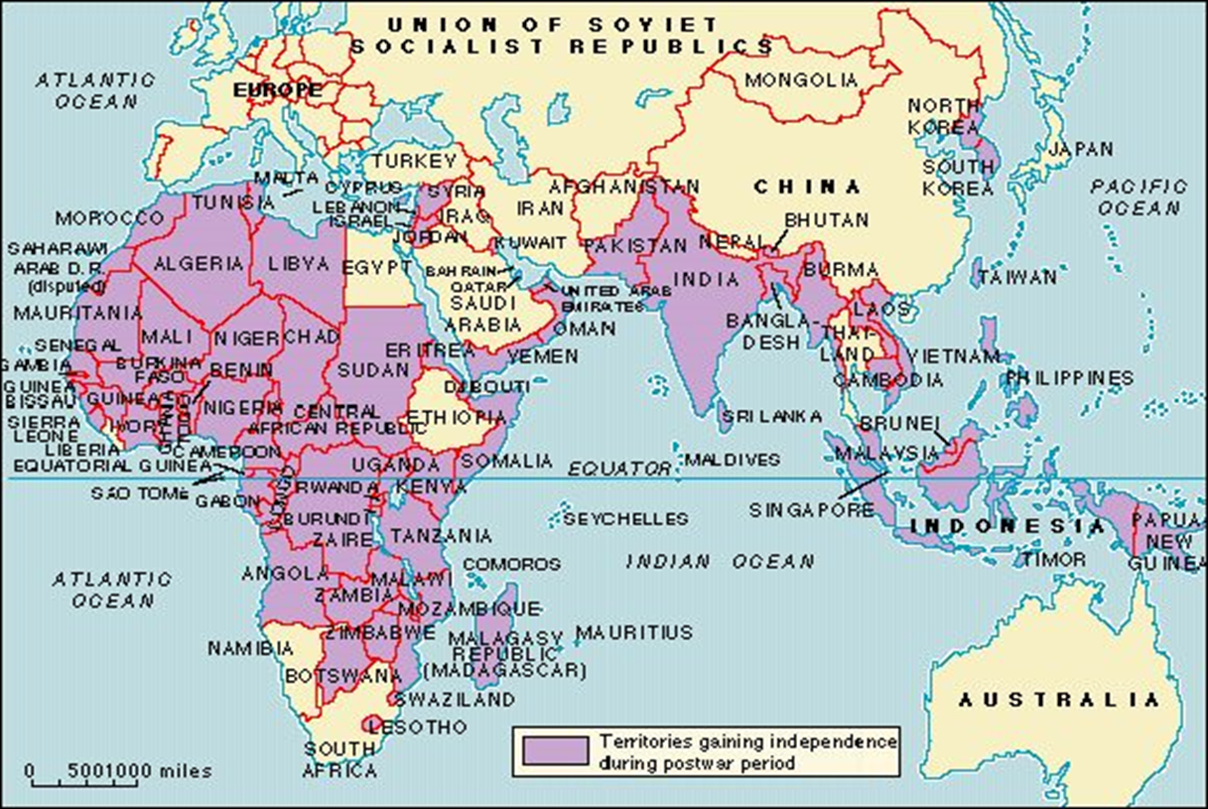
Here is a sample question:
'with reference to the source and your knowledge of history, what were the factors that led to the decline of colonialism?' Here's a decent answer to that question:
In the years that followed World War II, many colonies of the world sought for and gained their independence. There were a number of factors that motivated this decline in colonialism. To begin with, Prime Minister Churchill of Great Britain and President Roosevelt of the United States, met in 1941 (in Placentia Bay, Newfoundland!!!) to sign the Atlantic Charter. In this document they both declared that they believed in the idea of self-determination. That means that countries of the world should have the right to choose their own government. Colonies embraced the idea. They believed that they deserved independence after the contributions they had made during World War II. Another factor that motivated the decline was the fact that Britain and the other European powers were broke after the war. They could no longer afford to manage large colonial empires. Two final factors also brought about the decline of colonialism. They were: the United States encouraged nations to become independent and claimed to sympathize with them, having once been a colony themselves; also the Soviet Union disagreed with colonialism and wanted to see colonies become independent states – hopefully independent communist states. The source above is a quote by Ghandi of India. Ghandi was a former lawyer, who adopted a lifestyle of poverty to show solidarity with the people. He promoted the idea of peaceful, civil disobedience in an attempt to show how unjust it was for Britain to be ruling India. In 1930 for example, he led thousands of people on a march of almost 400 km to the sea to make salt. This was against the law and the government had to arrest around 80,000 of them. That was impossible, even if they didn't resist. In the end the British granted India its independence in 1947. As a result of his ideas of peaceful, non-violent protest, Ghandi will forever be remembered as one of the very good people in history.

•5.1.5 Assess the methods used by Mahatma Gandhi, Gamal Abdel Nasser and Nelson Mandella to promote nationalism and independence, and judge the effectiveness of each.

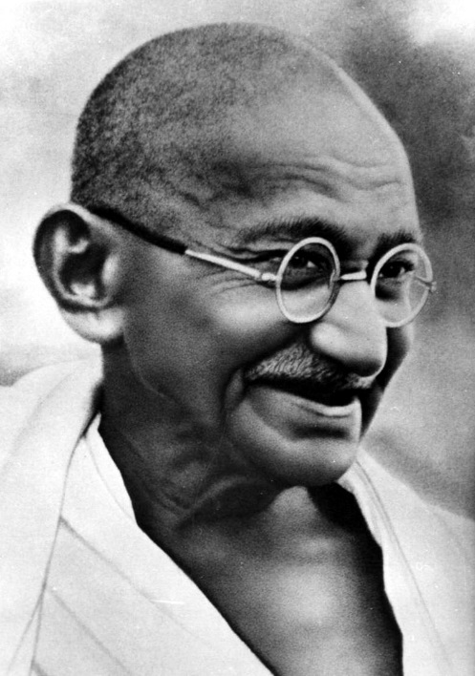
Gandhi
-The best way to find yourself is to lose yourself in the service of others- Mahatma Gandhi
Gandhi Leads India to Independence: For 200 years Britain ruled India and did not want to give up this valuable colony. Gandhi, trained as a lawyer in Britain, returned to India in 1915 to lead India’s struggle to independence. The methods Gandhi used to achieve independence were non-violence and civil disobedience. Gandhi believed that Indian people had the right to freedom and self rule. Because Britain deprived India of its independence, Gandhi felt they should resist or break British law. Gandhi thus encouraged Indian people to refuse to obey morally intolerable laws (Salt Tax). This is civil disobedience.
Some examples of civil disobedience were:
• resign from government jobs
• stop buying British goods
• refuse to pay taxes
• Purposely break unfair laws (1930 Salt March for example)
Gandhi insisted that his followers not respond to the British with violence. If Indians were protesting and police clubbed them. Gandhi insisted that they not only not hit back but not even shield themselves from the attack. This was non-violence. Gandhi believed that the British would be defeated not when they had no strength but when they had no heart to fight against a moral, non-violent people. Gandhi’s methods were eventually successful and India became independent in 1947.

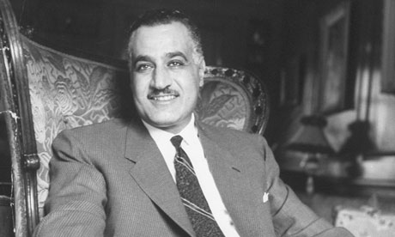
Nasser
-There is no longer a way out of our present situation except by forging a road toward our objective, violently and by force, over a sea of blood and under a horizon blazing with fire- Gamal Abdel Nasser
Nasser Creates An Independent Egypt: Egyptian nationalism increased the growing criticism of Egypt’s monarchy as corrupt. Egypt’s defeat by Israel in the war of 1948 caused humiliation among Egyptian soldiers. Pledging to restore Arab pride, Nasser and others formed a Free Officers movement aimed at driving out foreign powers. In 1952 army officers forced the Egyptian King Farouk to abdicate. The monarchy was abolished and a new republic, with Nasser as president, was established in 1956. Nasser was celebrated in Egypt for standing up to Europeans, redistributing wealth to improve the lives of citizens and pledging to restore Palestine to Palestinians.

Mandella
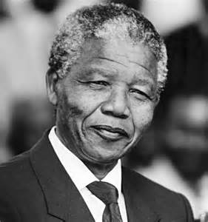
-I learned that courage was not the absence of fear, but the triumph over it. The brave man is not he who does not feel afraid, but he who conquers that fear.-Nelson Mandella
Mandella Fights Apartheid in South Africa: In 1948 apartheid was introduced to South Africa. This racial policy separated South Africa into classes - a privileged white ruling class and an exploited subservient class. Whites controlled the political, educational and economic institutions for their advantage. Nationalist groups such as the African National Congress (ANC) began using boycotts, strikes, and demonstrations to attack racial discrimination in South Africa. The South African government responded by arresting ANC leaders such as Nelson Mandela. Mandela joined the ANC in 1944 and in the 1950's he organized non-violent resistance against apartheid. Following the Sharpeville massacre in 1960 Mandela and others abandoned non-violent protest in favour of violent acts. As a result Mandela was sentenced to life imprisonment in 1963. While in prison from 1963 - 90 Mandela became an international figure with a worldwide following of supporters. He repeatedly refused offers of freedom in exchange for keeping quiet about apartheid. This elevated him to mythical status among black South Africans. Eventually his fame grew that world leaders and the UN applied political pressure for Mandela’s release. Musicians, artists and writers championed Mandel’s cause. Finally in 1990, the South African government facing civil unrest and world pressure, released Mandela. The government pledged reforms to create an equal and democratic South Africa. In 1994 Nelson Mandela was elected the first black president of South Africa.
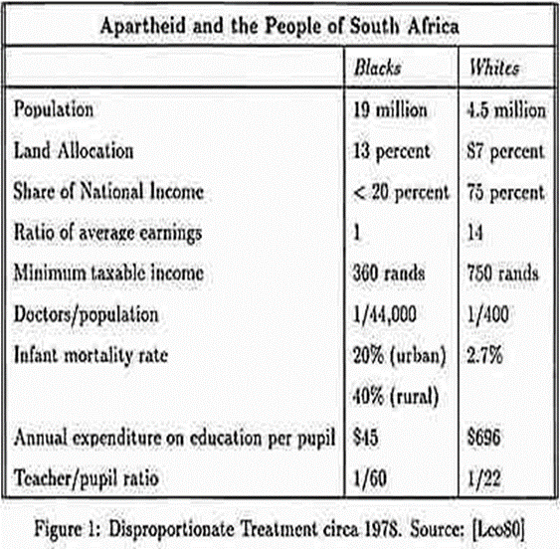
•5.1.6 Evaluate the political, economic and social impact of apartheid on race relations in South Africa.

Apartheid: After the National Party gained power in South Africa in 1948, its all-white government immediately began enforcing existing policies of racial segregation under a system of legislation that it called apartheid. Under apartheid, non-white South Africans (a majority of the population) would be forced to live in separate areas from whites and use separate public facilities, and contact between the two groups would be limited. Despite strong and consistent opposition to apartheid within and outside of South Africa, its laws remained in effect for the better part of 50 years. In 1991, the government of President F.W. de Klerk began to repeal most of the legislation that provided the basis for apartheid.

Birth of Apartheid
Racial segregation and white supremacy had become central aspects of South African policy long before apartheid began. The controversial 1913 Land Act, passed three years after South Africa gained its independence, marked the beginning of territorial segregation by forcing black Africans to live in reserves and making it illegal for them to work as sharecroppers. Opponents of the Land Act formed the South African National Native Congress, which would become the African National Congress (ANC).
The Great Depression and World War II brought increasing economic woes to South Africa, and convinced the government to strengthen its policies of racial segregation. In 1948, the Afrikaner National Party won the general election under the slogan “apartheid” (literally “separateness”). Their goal was not only to separate South Africa’s white minority from its non-white majority, but also to separate non-whites from each other, and to divide black South Africans along tribal lines in order to decrease their political power.

Apartheid Becomes Law
By 1950, the government had banned marriages between whites and people of other races, and prohibited sexual relations between black and white South Africans. The Population Registration Act of 1950 provided the basic framework for apartheid by classifying all South Africans by race, including Bantu (black Africans), Coloured (mixed race) and white. A fourth category, Asian (meaning Indian and Pakistani) was later added. In some cases, the legislation split families; parents could be classified as white, while their children were classified as colored.
A series of Land Acts set aside more than 80 percent of the country’s land for the white minority, and “pass laws” required non-whites to carry documents authorizing their presence in restricted areas. In order to limit contact between the races, the government established separate public facilities for whites and non-whites, limited the activity of nonwhite labor unions and denied non-white participation in national government.

Apartheid and Separate Development
Dr. Hendrik Verwoerd, who became prime minister in 1958, would refine apartheid policy further into a system he referred to as “separate development.” The Promotion of Bantu Self-Government Act of 1959 created 10 Bantu homelands known as Bantustans. Separating black South Africans from each other enabled the government to claim there was no black majority, and reduced the possibility that blacks would unify into one nationalist organization. Every black South African was designated as a citizen as one of the Bantustans, a system that supposedly gave them full political rights, but effectively removed them from the nation’s political body.
In one of the most devastating aspects of apartheid, the government forcibly removed black South Africans from rural areas designated as “white” to the homelands, and sold their land at low prices to white farmers. From 1961 to 1994, more than 3.5 million people were forcibly removed from their homes and deposited in the Bantustans, where they were plunged into poverty and hopelessness.

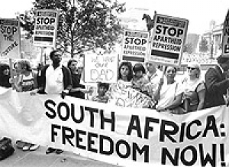
Opposition to Apartheid
Resistance to apartheid within South Africa took many forms over the years, from non-violent demonstrations, protests and strikes to political action and eventually to armed resistance. Together with the South Indian National Congress, the ANC organized a mass meeting in 1952, during which attendees burned their pass books. A group calling itself the Congress of the People adopted a Freedom Charter in 1955 asserting that “South Africa belongs to all who live in it, black or white.” The government broke up the meeting and arrested 150 people, charging them with high treason.
In 1960, at the black township of Sharpesville, the police opened fire on a group of unarmed blacks associated with the Pan-African Congress (PAC), an offshoot of the ANC. The group had arrived at the police station without passes, inviting arrest as an act of resistance. At least 67 blacks were killed and more than 180 wounded. Sharpesville convinced many anti-apartheid leaders that they could not achieve their objectives by peaceful means, and both the PAC and ANC established military wings, neither of which ever posed a serious military threat to the state. By 1961, most resistance leaders had been captured and sentenced to long prison terms or executed. Nelson Mandela, a founder of Umkhonto we Sizwe (“Spear of the Nation”), the military wing of the ANC, was incarcerated from 1963 to 1990; his imprisonment would draw international attention and help garner support for the anti-apartheid cause.

Apartheid Comes to an End
In 1976, when thousands of black children in Soweto, a black township outside Johannesburg, demonstrated against the Afrikaans language requirement for black African students, the police opened fire with tear gas and bullets. The protests and government crackdowns that followed, combined with a national economic recession, drew more international attention to South Africa and shattered all illusions that apartheid had brought peace or prosperity to the nation. The United Nations General Assembly had denounced apartheid in 1973, and in 1976 the UN Security Council voted to impose a mandatory embargo on the sale of arms to South Africa. In 1985, the United Kingdom and United States imposed economic sanctions on the country.
Under pressure from the international community, the National Party government of Pieter Botha sought to institute some reforms, including abolition of the pass laws and the ban on interracial sex and marriage. The reforms fell short of any substantive change, however, and by 1989 Botha was pressured to step aside in favor of F.W. de Klerk. De Klerk’s government subsequently repealed the Population Registration Act, as well as most of the other legislation that formed the legal basis for apartheid. A new constitution, which enfranchised blacks and other racial groups, took effect in 1994, and elections that year led to a coalition government with a non-white majority, marking the official end of the apartheid system.

Check out this article about the lasting impacts of apartheid
“South Africa still a chronically racially divided nation, finds survey”- David Smith
http://www.theguardian.com/world/2012/dec/06/south-africa-racially-divided-survey

6.1 The student will be expected to draw upon primary and/or secondary sources to demonstrate an understanding of selected security, economic and environmental challenges of the modern era.

•6.1.1 Define:
◦arms proliferation, the spread of dangerous arms/weapons throughout the world. This is seen as dangerous as it is feared dictators/terrorists would be more willing to use such weapons.
◦terrorism, a method of aggression that uses violence to create fear in an attempt to gain some goal; usually political.
◦human rights, the freedom granted to all people protecting them from unlawful arrest, torture, or execution.
◦ethnic cleansing, the displacement or murder of one ethnic group by another.

•6.1.2 Analyze examples to illustrate three peacekeeping roles that UN forces are sometimes called upon to perform in troubled areas.
◦mediation of disputes between conflicting parties
◦deployment of military forces to maintain peace in civil or international wars
◦deployment of military forces to ensure distribution of humanitarian aid

UN in Somalia:
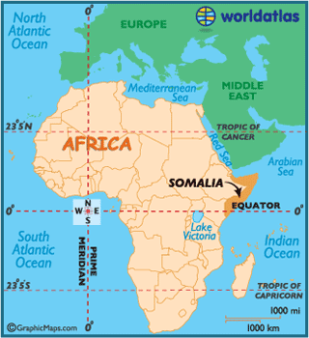
Background: The Republic of Somalia was created in 1960, 9 years later there was a military coup. For the next 20 years under the rule of a dictator (General Barre) democracy was eliminated, industries were nationalized, and human rights were abused. In 1988 civil war broke out in the drought stricken country as Somali clans opposed Barre. By 1991 Barre had control of Northern Somalia but warlords competed for political power in the South. Part of Mogadishu, in the South, was divided between Abgall (5000 guerillas) and Aidid (10,000 guerillas).
Famine spread throughout Somalia and 300,000 to 500,000 people died. Thousands fled to Mogadishu but the warlords controlled the food (supplied by UN) only giving it to people who supported them. These warlords also opposed the idea of UN military forces entering the country. Despite the best efforts of groups like UNICEF and Red Cross food destined for famine victims continued to be looted and used by those engaged on the civil war. By June 1992, 6 million faced starvation. In 1992, with Operation Restore Hope, the UN authorized the use of military force to ensure food reached the people of Somalia. In December a U.S. led operation arrived in Somalia which put UN soldiers in direct confrontation with the warring factions. In 1993 18 U.S. soldiers were killed and dragged through the streets of Mogadishu. As a result the UN mission in Somalia changed from humanitarian aid to demobilizing warring factions. Thousands died in clashes including dozens of peacekeepers. The UN was unable to maintain a cease fire, and so the mission ended in failure. UN troops were withdrawn in March 1995.* By 2000 the UN had set up a Transitional National Government to draw a constitution and hold elections.

•6.1.3 Analyze the role of recent UN peacemaking efforts in Somalia and Bosnia - Herzegovina.
UN in Bosnia-Herzegovinia:
Background: Josef Broz Tito ruled Yugoslavia from 1945 to 1980. Under Tito the country made up of six republics: Bosnia, Croatia, Macedonia, Montenegro, Slovenia and Serbia was prosperous, peaceful and independent. By 1990 the country had broken apart into competing ethnic and political groups. Yugoslavia’s breakup became a reality in June 1991 when Croatia and Slovenia separated from Yugoslavia and declared themselves independent. The Serbian - dominated Yugoslav army attempted to prevent the separations but failed. Fighting raged throughout 1991 resulting in the deaths of thousands. By the end of 1991 it was clear that the Serbia had failed to prevent the disintegration of Yugoslavia. The Serbs were now determined to prevent the separation of Bosnia-Herzegovina.
The population of Bosnia was 44% Muslim, 31% Serbian and 17% Croatian, the remainder being other ethnic groups. The Muslims and Croats voted in favour of independence in 1992. Serbia, unwilling to see the largest group of Serbs outside Serbia become a minority, within a new country, launched a full scale assault on Bosnia in an attempt to eliminate all Muslims and Croats. People were driven out of their homes, and houses were burned down to prevent the return Muslims or Croats. This policy of forcing ethnic groups out of a region became known as ethnic cleansing. The situation in the former Yugoslavia soon attracted world attention and intervention. The UN demanded an end to the violence but was ignored. The UN imposed harsh economic sanctions against Serbia and sent UN peacekeeping forces to Bosnia to protect the airport to protect relief shipments. However these forces did not have the ability to impose peace. Fighting continued throughout 1992 and by 1993 Serbia was expelled from the UN. UN peacekeeping forces were now threatened. Finally the U.S. was able to convince NATO to intervene militarily. In the end the region became a confusing mix of NATO peacemaking and UN peacekeeping– both failed to provide a lasting peace.*The Serbs would be defeated in 1999 by NATO when they invaded Kosovo.

•6.1.4 Assess how the re-emergence of nationalism, ethnic diversity and religious differences have created conflict in:
◦former Yugoslavia
◦Rwanda
◦India-Pakistan

Rwanda:
Rwanda is 85% Hutu and 15% Tutsi. Since the 1600's Tutsi hereditary kings ruled Rwanda. In 1959 the majority Hutu tribe overthrew the Tutsi monarchy and became independent in 1962.In 1973 there was a revolution and the new constitution limited the presidency to Hutus. Approximately 150,000 Tutsi were forced into exile. These exiles formed the Rwandan Patriotic Front (RPF) and invaded Rwanda in 1990. A peace agreement was signed in 1993. The UN went in to Rwanda to supervise the implementation of this treaty however events would soon overwhelm the UN. In 1994 the assassination of the Hutu president of Rwanda unleashed widespread chaos and death. Over a 13 week period the Hutu-dominated army killed more than 800 000 Tutsis. It became clear that extremist Hutus intended a genocide of the Tutsi population.

Former Yugoslavia:
Yugoslavia was a country made up of various religious and ethnic groups. The collapse of the Soviet Union triggered the breakup of Yugoslavia into competing ethnic and political groups. In June 1991two regions in Yugoslavia, Croatia and Slovenia declared themselves independent. The Serbian - dominated Yugoslav army attempted to prevent the independence of these regions. Fighting raged throughout 1991 resulting in the deaths of thousands. When the province of Bosnia-Herzegovina planned to become independent the Serbs became determined to prevent their separation. The population of Bosnia was 44% Muslim, 31% Serbian and 17% Croatian, the remainder being other ethnic groups. The Muslims and Croats voted in favour of independence in 1992. Serbia, unwilling to see the largest group of Serbs outside Serbia become a minority, within a new country, launched a full scale assault on Bosnia in an attempt to eliminate all Muslims and Croats. People were driven out of their homes, and houses were burned down to prevent the return Muslims or Croats. This policy of forcing ethnic groups out of a region became known as ethnic cleansing. Violence continued in Yugoslavia in 1998 when the province of Kosovo protested Sebia’s control of them. Civil war broke out with Serbian forces killing thousands of Albanians who were the largest ethnic group in Kosovo. There was international intervention in 1999 when it became clear that the Serbs were implementing a policy of ethnic cleansing.

India-Pakistan:
Pakistan and India have always disagreed over India’s control of Kashmir. In the 1980's Muslim militants in Kashmir have pushed for separation. India accused Pakistan of supporting the campaign while Pakistan claims the Muslim Kashmiris were simply demanding self-determination. By 1990 the situation deteriorated as hundreds of thousands of Muslims took part in demonstrations. Indian troops fled into the region with the result being rising civilian casualties. As well Indian and Pakistani troops skirmished along the border. The future of Kashmir remains a source of friction between India and Pakistan.

•6.1.5 Assess how the quest for nuclear capability by Iraq and North Korea have affected global security.

The end of the Cold War brought hope for global relationships that did not depend on military threats the accompanying quest for weapons of mass destruction (WMD) did. Throughout the 1990's many treaties were signed eliminating or reducing WMD. Unfortunately such treaties could not solve the existence of nuclear weapons technology and the desire of some countries to develop them. Some nations, Iraq, North Korea and Iran began to shopping to buy materials and expertise to establish nuclear arsenals. These countries justified the development of their own nuclear weapons because countries such as the U.S, Russia and China had theirs. Some people feel the threat of nuclear war has increased because of the desire of more countries to develop nuclear arsenals. They may be right. Following the attack on the World Trade Center on Sept. 11, 2001 President Bush said that the countries of Iraq, Iran and North Korea formed an “axis of evil” that promoted terrorism and possessed weapons of mass destruction. As result of this thinking the U.S. declared war on Iraq in 2003. Though the U.S toppled Iraq’s leader, Saddam Hussein, it seems that terrorist activity in this region of the world has only escalated. Thus making the world a more dangerous place.

•6.1.6 Analyze how terrorist attacks such as those on the World Trade Centre and suicide bombings in Israel have posed threats to world peace and security.

Terrorist attacks on the World Trade Center and suicide bombings in Israel have threatened world peace. Though it can be argued that the terrorists are freedom fighters to many in their region, there is no doubt that their actions and the response of the U.S. and Israel have threatened world peace. To demonstrate the threat of terrorism to world peace we need only focus on the World Trade Center attack. Following this attack political leaders around the world supported the U.S. when it declared “war on terrorism”. Once Osama Bin Laden and his terrorist organization al-Queda were identified, many nations aided the U.S. attack on Afghanistan when this nation protected al-Queda. Though this war was quickly won there had been a threat to world peace. The threat to world peace resulting from these attacks unfortunately has increased. U.S. President Bush feels that other nations such as Iraq support terrorism. As a result Bush has ignored the UN and invaded Iraq. Though the U.S. quickly defeated Iraq’s dictator it seems that terrorism in the region has increased. Many argue that the war in Iraq has created more terrorists who will commit more acts of terrorism. Who knows where this will end. Obviously it is clear to say that terrorism and the responses to it threaten world peace.

•6.1.7 Explain how the European Union has moved toward greater economic integration with reference to:
◦common currency
◦trade policy
The two world wars in the first half of the 20th century left Europe ravaged. The new nuclear arms race and nationalism still divided Europe. European leaders, such as Winston Churchill felt European countries should set aside old differences and strengthen the ties of European countries economically and politically. The idea was that if Europe was integrated economically it would reduce nationalism. Beginning in 1949 European nations began establishing trade agreements to increase European cooperation. Since 1949 different trade agreements and organizations have united Europe into an economic zone now referred to as the European Union. As of April 19, 2004 this union includes 25 European countries united in common economic and humanitarian goals. The most symbolic part of this Union is a new currency The Euro which it is hoped all countries will use in the future. The Euro is symbolic of the new unity of Europe.

6.1.8 Explain how the European Union has moved toward greater economic integration with reference to:
- Common currency
- Trade policy

