World History 3201 - Unit 01
Unit 1: The First World War: 1914-1918
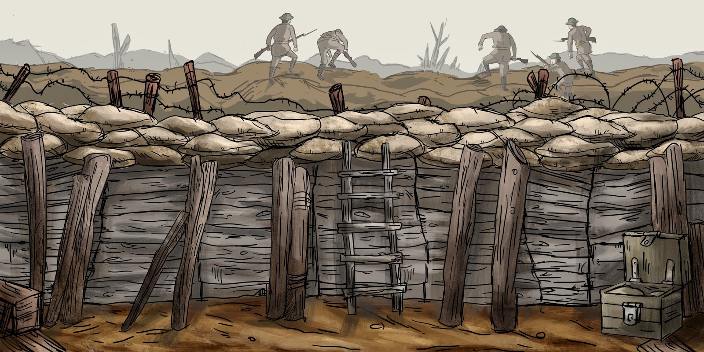

Important terms:
1. Alliances: formal agreements between countries or nations which states that in case of threat, one country will cooperate and protect the other. This was a major cause of WW1.
2. Nationalism: the strong sense of pride in one’s country and loyalty towards that country.
3. Economic Rivalry: competition between nations to produce the greatest economic growth. A belief that one country should be better and bigger than another by means of money, land, resources, etc. During the years leading up to WW1, Germany and Britain were in constant competition for bigger and better factories, industries and territories.
4. Arms Race: Competition between rival states to gain superior military weapons and technologies.
5. Alliance system: the division of Europe into two rival camps: the Triple Entente and the Triple Alliance.
**p. 21 South African War**

1.1 Students will be expected to draw upon primary and/or secondary sources to demonstrate an understanding of the causes of World War I.
1.1.1 Define:
Imperialism: policy by which powerful nations or peoples seek to extend and maintain control or influence over weaker nations or peoples. Historically, states have been motivated to pursue imperialism for a variety of reasons, which may be classified broadly as economic, political, and ideological.
Economic explanations of imperialism are the most common. Proponents of this view hold that states are motivated to dominate others by the need to expand their economies, to acquire raw materials and additional sources of labor, or to find outlets for surplus capital and markets for surplus goods.
Political determinants of imperialism, contending that states are motivated to expand primarily by the desire for power, prestige, security, and diplomatic advantages.
Ideological /Moral motives. According to this perspective, political, cultural, or religious beliefs force states into imperialism as a "missionary activity". Britain's colonial empire was motivated at least in part by the idea that it was the "white man's burden" to civilize "backward" peoples. Germany's expansion under Hitler was based in large measure on a belief in the inherent superiority of German national culture.
Nationalism: A sense of national consciousness that fosters loyalty to one's country.In modern history, the nation-state is regarded as paramount for the realization of social, economic, and cultural aspirations of a people. Nationalism is characterized principally by a feeling of community among a people, based on common descent, language, and religion.
Colony: a territory that is controlled by another power/powerful nation. Imperialistic countries sought to control other regions of the world which became their colonies.
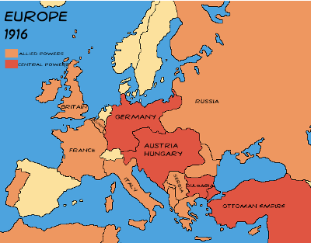
Triple Alliance: Alliance initiated by Germany that united Germany, Austria-Hungary and Italy. Its purpose was to isolate France in the event of War.
Triple Entente: Alliance between France, Russia and Britain that was formed in response to the rising powers of Germany, Austria-Hungary and Italy (The Triple Alliance).
Ultimatum: A final proposal of terms which, when rejected, may end negotiations and result in war.

PAX BRITANNIA: a period of general international peace under the military power of Britain.

NOBLE DESTINY: the belief that a course of events is predetermined by superior status and ideals.

DREADNOUGHT: a battleship introduced by Britain in 1906 that represented a revolution in naval shipbuilding.

TRENCHES: deep ditches in which the troops lived at the front during WW1. After WW1 trench warfare disappeared.

ALLIES: Britain, France, Russia and other countries.

CENTRAL POWERS: Germany, Austria-Hungary, Italy.

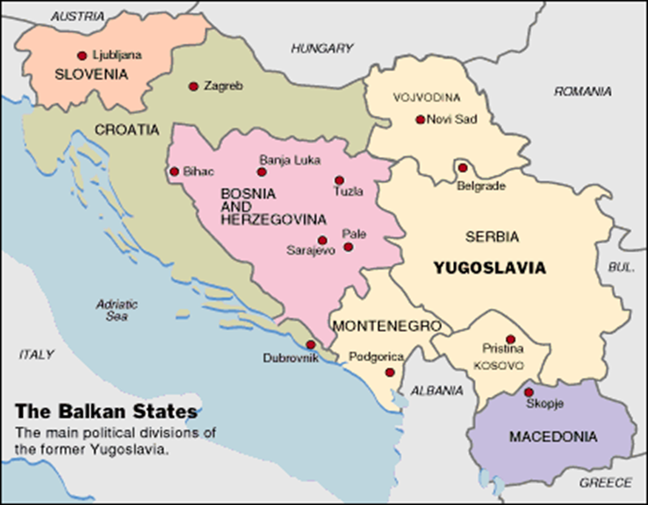
BALKANS- an area in Europe which included Bosnia, Herzegovina, Serbia, Bulgaria and parts of Greece. Turkey, Austria-Hungary and Russia all had conflicting interests in this area, which was bound to cause conflicts.
"The Balkans was like a powder keg ready to explode."

1.1.2 Identify on a map the major world empires in 1900. * see weebly for a clear map
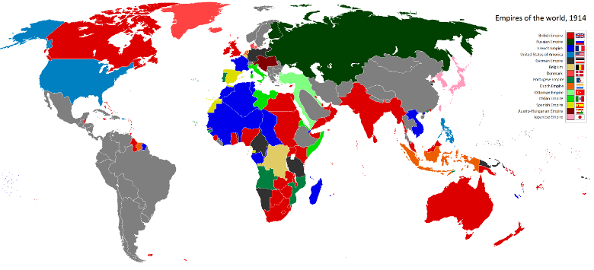

1.1.3 Analyze reasons for expansion of the major imperial powers at the turn of the twentieth century.
Historically, states have been motivated to pursue imperialism for a variety of reasons, which may be classified broadly as economic, political, and ideological.
1. Economic Reasons: Proponents of this view hold that states are motivated to dominate others by the need to expand their economies, to acquire raw materials and additional sources of labor, or to find outlets for surplus capital and markets for surplus goods.
2. Political Reasons: contend that states are motivated to expand primarily by the desire for power, prestige, security, and diplomatic advantages.
3. Ideological/Moral Reasons: According to this perspective, political, cultural, or religious beliefs force states into imperialism as a "missionary activity". Britain's colonial empire was motivated at least in part by the idea that it was the "white man's burden" to civilize "backward" peoples. Germany's expansion under Hitler was based in large measure on a belief in the inherent superiority of German national culture.

1.1.4 Analyze the origins of World War I with reference to
nationalism
economic rivalry (imperialism)
arms race
military alliances
World War I which lasted from 1914 to 1918, was the first great global conflict. More soldiers were killed in World War I than any other war in history. The war was caused by a number of ideologies that were held by European countries at the time. Driven by a need for natural resources, countries such as Britain and France and Belgium and Germany wanted to build huge empires around the world. The practice was known as imperialism. They completely took over other nations with a policy known as colonialism. They built huge armies in an effort to defend these empires and strengthen their country's influence around the world. This was known as militarism. During this time, the people of the European countries had a huge sense of pride and patriotism toward their country. So much so that they were prepared to go out and fight and die for it. One last cause of World War I would be the practice of forming alliances with other empires to protect against foreign powers. Ex: If Austria Hungary invades Serbia. Serbia's alliance with Russia will bring Russia into the war. Austria Hungary however, was part of an alliance with Germany and Italy called the Triple Alliance, and Russia was part of an alliance with Britain and France called the Triple Entente. The result was that a little conflict between Austria Hungary and Serbia would result in the whole world fighting because of the alliance system.

1.1.5 Analyze the role of Germany in the formation of military alliances before World War I with reference to:
• Dual Alliance 1879
• Triple Alliance 1882
• Reinsurance Treaty 1887
Otto von Bismarck, the German chancellor who unified Germany, engineered an alliance system in the 1880s.
- Dual Alliance (1879): an alliance between Ger. and Austria-Hun.
- Triple Alliance (1982): Italy was drawn into the alliance between Ger. And Austria-Hun.
- Reinsurance Treaty (1887): an agreement between Ger./Russia. Both countries agreed to remain neutral if the other was attacked by a third power.
- Bismarck also opposed Ger. imperialism and resisted naval expansion to avoid a conflict with Britain.
- In 1888, the new emperor dismissed Bismarck and acted as Chancellor himself. He allowed the Reinsurance Treaty to lapse.
- Russia, concerned about Germany, entered an alliance with France in 1894 (they had been traditional enemies since the Napoleonic Wars).
- Britain, alarmed at Ger. naval expansion, ended its policy of “splendid isolation” and joined with France and Russia to form the Triple Entente in 1907.

Triple Alliance: Germany, Austria-Hungary, and Italy

Triple Entente: Britain, France, and Russia

* a dispute between any 2 members of opposite alliances would involve all 6 in a general conflict.

1.1.6 Create a time line of the major steps to war between June 28 - August 4, 1914.
The Steps to War, June 28 to August 4, 1914:
June 28: Archduke Ferdinand of Austria was assassinated in Bosnian city of Sarajevo by Bosnian Serb nationalist (Gavrilo Princip of the Black Hand).
July 23: Austrian government gives Serbia 48-hour ultimatum. Serbia does not agree to all terms and begins to mobilize.
July 28: Austria-Hungary declares war on Serbia; Serbia turns to Russia for help.
July 29: Czar Nicholas of Russia agrees to help Serbia and mobilizes army.
July 30: Germany sends Russia ultimatum to halt mobilization; Russia refuses.
August 1: Germany declares war on Russia; France mobilizes army.
August 2: Germany invades “neutral” Belgium as part of the Schlieffen Plan for attacking France.
August 3: Germany declares war on France; Britain gives Germany an ultimatum to halt invasion of Belgium.
August 4: No reply from Germany; Britain declares war on Germany; Canada automatically at war as part of the British Empire; U.S. declares neutrality.

1.1.7 Draw conclusions about the impact of the assassination of Archduke Franz Ferdinand on the outbreak of World War I in terms of:
Serbian nationalism
- the assassination was an expression of Serbian nationalism.
- It expressed the sentiment that the Serbs wanted to unite all Serbs within the one greater Serbia.
- This included the Serbs situated in Bosnia-Herzegovina, which was a territory annexed from Serbia by Austria-Hun.
- It was this Serbian nationalism that the Austro-Hungarian Empire wanted to stamp out, perceiving it as a rising threat to their Empire.

Austro-Hungarian/Serbian relations
Austro-Hungarian/Serbian Relations:
- the assassination led to a deterioration of relations between these two regions.
- The Austro-Hungarians saw this event as a threat to their Empire and saw in it, an excuse to take action to reduce Serbian influence in the area.

German government’s response
German Government’s Response:
- The German government’s response to the assassination was to assure Austria-Hun of its support in dealing militarily with Serbia.
- Austria-Hun wanted Germany’s assurance that they would come to Austria-Hun’s aid if Russia decided to enter the dispute on Serbia’s side.
- Germany’s expressed support for Austria-Hun and gave them the assurance they needed in order to issue the ultimatum to Serbia and then act militarily when Serbia did not agree to the terms of this ultimatum.
- With Germany anticipating a possible conflict with Britain and France, dealing with this Serbian menace now would put Austria-Hun. In a better position to fulfill their obligations as a member of the Triple Alliance should a war break-out.

Russian mobilization
Russia Russian Mobilization:
- Russia’s mobilization of its forces assured Serbia of its backing for the Serbs in their dispute with Austria-Hun.
- This mobilization was a clear signal to the Serbs that Russia was willing to intervene militarily on their behalf in the dispute with Austria-Hun.
- It gave the Serbs the confidence to reject the ultimatum and assured them that Russia would be there to help in the event that Germany became involved.

1.1.8 Assess how German and British attitudes toward war on the eve of World War I contributed to rivalry and conflict.
In the late 1800s and early 1900s, Britain was often described as being in 'Splendid Isolation' from the rest of Europe. Britain had a huge empire and ruling this empire was its priority. The key to Britain's power was India with its vast resources of manpower. Britain relied heavily on Indian troops to control the empire. The highest priority for Britain was protecting the trade routes between Britain and India. Britain's large navy protected trade links with India and with the rest of the world.
Despite this focus on the empire, Britain was interested in events in Europe. To start with, other European countries had rival empires. Belgium and France both had large empires in Africa. There was strong rivalry between Britain and France over possessions in North Africa. By the early 1900s, Germany also had colonies in Africa and was beginning to show an interest in North Africa.
Another concern was Russia. For much of the 19th century, Russia wanted to take control of the Dardanelles, the area where the Black Sea opened out into the Mediterranean Sea. This would allow Russian warships and trading ships to sail easily around Europe. Russia had other ports in the north, but these tended to freeze over in winter. The problem was that the Dardanelles were owned by Turkey. Turkey and Russia had long been enemies. Britain supported Turkey against Russia. This was because Britain did not want Russian ships in the Mediterranean. The Mediterranean was part of Britain's most important trade route to India.
Until the early 1900s, Britain was more concerned about Russia and France than Germany. Relations between Britain and Germany were very good. This began to change, however. When Kaiser Wilhelm II took control of Germany, he was anxious for Germany to be a great power. He felt that Russia to the east and France to the west were encircling Germany. As a result, he built up his armed forces. France and Russia feared Germany and did the same. During the 1900s, all of the great powers in Europe began to build up their armies and navies.
British policy in Europe intended that no country in Europe should become completely dominant. If Russia, France, Germany and Austria-Hungary worried about each other, then they would be less of a threat to Britain. By about 1907 it was becoming clear to Britain that the greatest potential threat to Britain was going to be Germany. The strong economy, large population and powerful armed forces of Germany seemed to be capable of dominating Europe. As a result, Britain began to support Russia and France. Britain joined the Triple Entente.
Despite being part of the Triple Entente, Britain was not committed to going to war in 1914. The Foreign Secretary, Sir Edward Grey, spent much of the summer of 1914 furiously trying to reassure Russia and Germany and prevent a war happening. Even when German troops invaded France and Belgium as part of the Schlieffen Plan, Britain did not have to go to war.

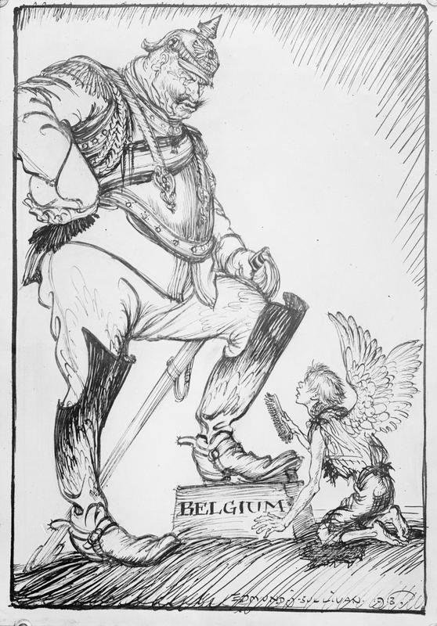
Germany hoped Britain would stay out of the war altogether. However, the Germans knew that Britain had promised to defend Belgium under the Treaty of London of 1839. The Germans wanted the British government to ignore the Treaty of London and let the German army pass through Belgium. The British government made much of their duty to protect Belgium. Belgium's ports were close to the British coast and German control of Belgium would have been seen as a serious threat to Britain. In the end, Britain refused to ignore the events of 4 August 1914, when Germany attacked France through Belgium. Within hours, Britain declared war on Germany. The Kaiser said how foolish he thought the British were. He said that Britain had gone to war for the sake of a "scrap of paper".
Within a few more days, Britain, France and Russia (the Allies) were all officially at war with Germany and Austria-Hungary (the Central Powers). What had started as a small, local problem in the Balkans was turning into the biggest and most brutal war the world had ever seen.

1.2 Students will be expected to draw upon primary and/or secondary sources to demonstrate an understanding of important events of World War I.

1.2.1 Define:
Schlieffen Plan: This was Germany’s plan for a quick assault on France and Russia to win World War I. The plan called for the concentration of almost the entire German army to avoid the heavily armed and defended French-German border and, instead, to attack France through neutral Belgium. After encircling and defeating the French, the Germans would then shift their forces to the east to defeat Russia, who were expected to be slow to mobilize.
Battles of the Marne 1914: This battle took place in September, 1914 after the Germans had advanced into France under the Schlieffen Plan. An Allied line of defence was established along the River Marne north of Paris. As the Germans advanced, the Allied forces held and launched a counterattack. This stalled the German offensive and both sides dug their line of trenches and settled in for a long war of attrition.
Battles of the Marne 1918: On July 18, 1918 the Allies began a major counteroffensive near the Marne River again. With French light tanks leading the way and bolstered by eight American divisions, the allies pushed the German lines back over the Marne. This marked the turning point in the war on the Western Front.
Battle of Tannenberg: In August 1914, the Germans out-manoeuvred a much larger Russian force and won a major battle. The Russian supply system had failed and their communications had broken down. Unaware of German troop movements, the Russians made fatal decisions regarding the deployment of their troops and, as a result, the Second Russia Army was surrounded and destroyed. This battle shows how, on the Eastern Front, the front was mobile (moving) as opposed to a stalemate like on the Western Front.
Battle of the Somme (Beaumont - Hamel): The British inspired Somme offensive in July 1916 was designed to be a smashing breakthrough of the German lines that would be the turning point in the war. Instead, it turned into a horrific killing field where hundreds of thousands of men were sacrificed for a few metres of mud. Beaumont-Hamel (Newfoundland Regiment) was part of this battle.
Zimmerman Telegram: A telegram sent by Germany’s Foreign Minister (Arthur Zimmerman) to Mexico. It suggested that Mexico should make an alliance with Germany if the United States joined the war. Mexico was promised they would reconquer lost territory in Mexico, New Mexico, and Arizona. The Americans intercepted the telegram and it became one of the factors that contributed to the United States joining the war against Germany.
Treaty of Brest-Litovsk: This treaty, signed in March 1918, ended Russia’s involvement in World War I. Russia lost one-third of its population and its agricultural land and Germany was no longer fighting on two fronts.
Armistice: A formal agreement between warring nations to stop fighting. This was officially declared on the eleventh hour of November 11, 1918.
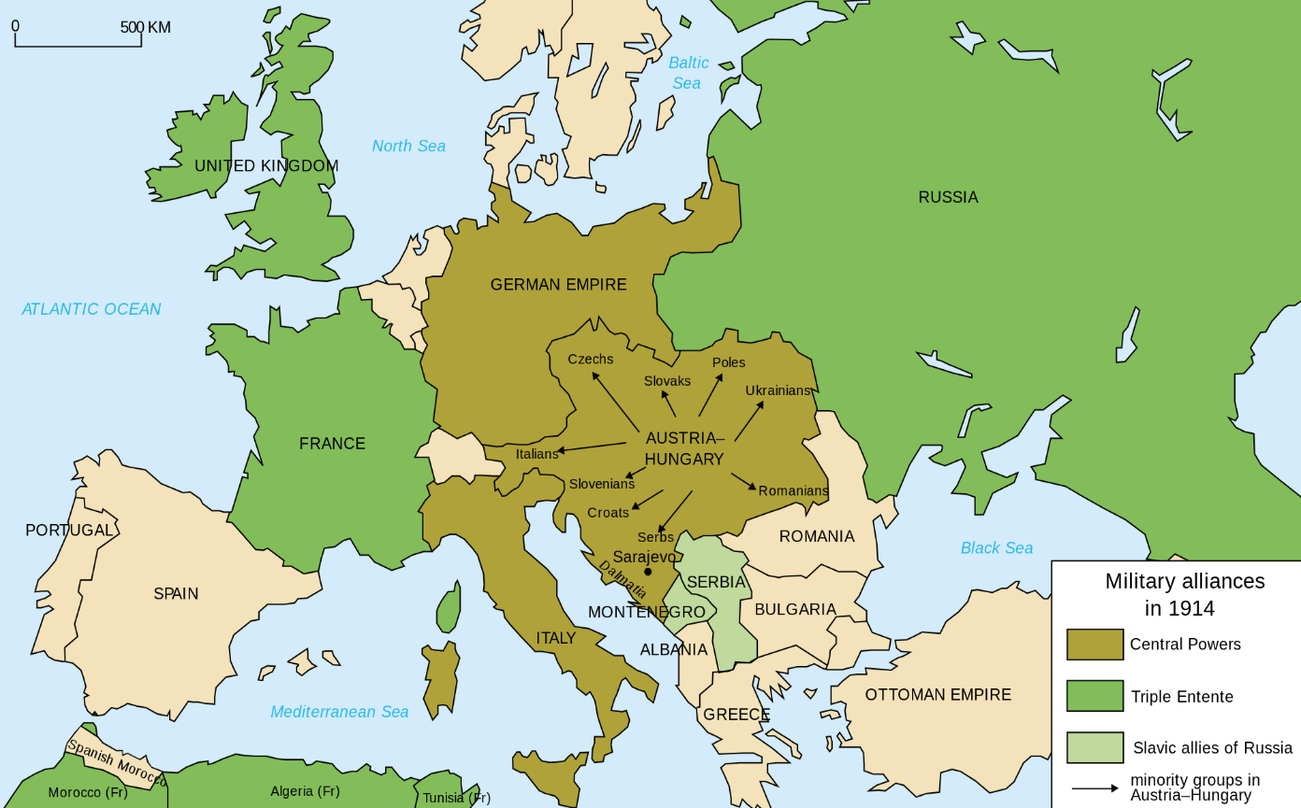
1.2.2 Identify on a map the main members of the Allied Powers and Central Powers.

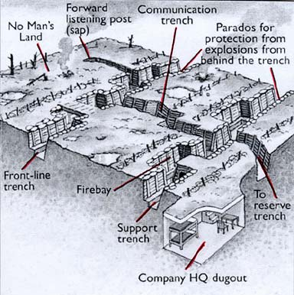
1.2.3 Explain how trench warfare contributed to a stalemate on the Western Front.
Pretty simple, after the race to the sea, armies began to dig in trenches to hold their line. The area between trenches called “no mans land” was deadly, full of barbed wire, explosives, and enemy fire (guns and tanks behind enemy lines). As the trench system became more elaborate and expansive it was easy for armies to wait for an enemy attack, because going “over the top” to begin your own offensive almost always ending badly. Armies on both sides made very few territorial advances throughout the war, this is known as a stalemate.

1.2.4 Examine the impact of each new military technology on the nature of war during World War I:
machine guns
tanks
submarines
aircraft
gas

1.2.5 Compare and contrast the nature of the war on the Eastern and Western Fronts.
During World War I, Germany under Kaiser Wilhelm II fought a two-front war against French, British, Belgian, and (later) American forces on the Western Front while simultaneously fighting the Russians on the Eastern Front, until the Bolshevik Revolution of 1917 took Russia out of the war. Germany had foreseen such a scenario, and developed the Schlieffen Plan in order to counteract being surrounded by its enemies. Under the Schlieffen Plan, German forces would invade France via Belgium, Luxembourg, and the Netherlands (the idea to go through the Netherlands was abandoned because of the country's neutrality), quickly capturing Paris and forcing France to sue for peace. The Germans would then turn their attention to Russia in the east before the Tsar could mobilize his massive forces. Due to several factors however, the Germans failed to achieve the plan's aim.
The Western Front was the main theatre of war during World War I. Following the initial race to the sea, both sides dug in along a meandering line of fortified trenches, stretching from the North Sea to the Swiss frontier with France. This line remained essentially unchanged for most of the war.
Between 1915 and 1917 there were several major offensives along this front. The attacks employed massive artillery bombardments and massed infantry advances. However, a combination of entrenchments, machine gun nests, barbed wire, and artillery repeatedly inflicted severe casualties on the attackers and counter-attacking defenders. As a result, no significant advances were made. Among the most costly of these offensives were the Battle of Verdun, in 1916, with a combined 700,000 casualties (estimated), the Battle of the Somme, also in 1916, with more than a million casualties (estimated), and the Battle of Passchendaele, in 1917, with roughly 600,000 casualties (estimated).
In an effort to break the deadlock, this front saw the introduction of new military technology, including poison gas, aircraft and tanks. But it was only after the adoption of improved tactics that some degree of mobility was restored. The German Army's Spring Offensive of 1918 was made possible by the Treaty of Brest-Litovsk that marked the end of the conflict on the Eastern Front.
At the onset of WWI, most military leaders and politicians, along with the general public, assumed that any conflict would be short. New technologies like the machine gun and advances in heavy artillery, they reasoned, gave the attackers such firepower that static defenses could not hold out long. The Eastern Front saw the realization of nearly all of the predictions about modern military conflict. For four years, the Germans, Russians, and Austro-Hungarians fought a war of movement. Rapid movement and concentration resulted in stunning “cauldron battles;” tactical and technical developments led to large-scale breakthroughs and advances (or retreats) of hundreds of miles. The only prediction that was not realized, in fact, was that the war would be decided quickly. On the Eastern Front, as on the Western, the conflict dragged on for years, with neither side truly able to deliver a knock-out blow. As Winston Churchill (1874-1965) famously noted, “In the west, the armies were too big for the land; in the east, the land was too big for the armies.”

1.2.6 Describe two reasons the United States joined the Allied Powers in 1917.
The United States entered the war because of the Germans' decision to resume the policy of unrestricted submarine warfare, and the so-called "Zimmerman telegram," intercepted by the British, in which Germany floated the idea of an alliance with Mexico.
In 1914, the US intended to stay out of a conflict that seemed emblematic of the rottenness of old Europe, a place from which most Americans were thankful to have escaped. Step by step, the US was dragged in. Woodrow Wilson won the 1916 election vowing to maintain neutrality. Germany’s actions, though, made Americans change their minds. In May 1915, a German U-boat sank the British liner Lusitania, killing 1,198, including 129 Americans. This and other sinking’s piled further pressure on Wilson for the US to join the offensive
The revelation of the ‘‘Zimmermann Telegram’’ — a signal intercepted and deciphered by British intelligence from Germany’s foreign minister to his man in Mexico, offering the Mexicans the return of territories lost to the US if they joined the war on Germany’s side — helped generate support for war. On April 6, 1917, Congress voted to declare war on the Kaiser and his allies. Until then, America had done very well out of the war. Exports to Europe boomed and its financial institutions piled into markets previously dominated by Britain. Such a momentous step required momentous justifications and Wilson was the man to provide them.
US intervention would ensure this was “the war to end all wars”, said Wilson, and America would be fighting to make “the world safe for democracy”. Troops would not start arriving in large numbers until 1918, but their appearance was decisive.

1.2.7 Analyze how the American entry into World War I and the Russian withdrawal from World War I affected the Allied war effort and the war’s outcome.
US: On the battlefields of France in spring 1918, the war-weary Allied armies enthusiastically welcomed the fresh American troops. They arrived at the rate of 10,000 a day, at a time when the Germans were unable to replace their losses. After British Empire, French and Portuguese forces had defeated and turned back the powerful final German offensive (Spring Offensive of March to July, 1918), the Americans played a role in the Allied final offensive (Hundred Days Offensive of August to November), the infusion of new and fresh U.S. troops greatly strengthened the Allies' strategic position and boosted morale. The Allies achieved victory over Germany on November 11, 1918 after German morale had collapsed both at home and on the battlefield.
Russia: The Treaty of Brest-Litovsk and Russia’s departure from the war posed a serious danger to the Allied forces as it effectively closed the eastern front and thus meant that the Allies would soon face some 900,000 additional German troops on the western front. In addition, the large quantities of Russian equipment that the Germans captured would also now be used on the Allies. The United States provided the only possible hope to counter this sudden turning of the tables, but U.S. forces were not expected to begin major combat operations until the summer of 1918. On the whole, one might argue that Russia’s pullout, rather than bring the world closer to peace, likely extended the conflict by enabling Germany and Austria-Hungary to focus their entire attention on the west and south.
For Russia itself, the exit from the war cost most of the territorial gains the country had made since the reign of Peter the Great in the early 1700s. Although the Bolsheviks pronounced themselves Russia’s new leaders, their practical control extended little beyond Petrograd and Moscow. The war had drained Russia: 1.7 million of its soldiers had died in battle, and 3 million Russian civilians had perished as well. Moreover, the country was left in chaos, as there were still large groups of people remaining in Russia who opposed the Bolsheviks’ rule. Some sought to bring back the tsar; others favored a democratic government akin to the one promised by the provisional government that the Bolsheviks had overthrown. In the end, though Russia got out of World War I, the civil war that soon started within the country turned out to be even more costly for its people than World War I had been.

1.2.8 Analyze the social, economic and political impact World War I had on Canada.
social (change in the status of women)
economic (stimulation of Canadian industry)
political (greater Canadian role in international relations)

1.2.9 Assess the issue of responsibility for the outbreak of World War I.
Every country involved can take some share of the blame:
- Serbia might not have endorsed the Black Hand officially but they certainly sympathized with and supported this terrorist group.
- Austria Hungary annexed Bosnia and aggravated tensions in the Balkans; and it was Austria Hungary that gave the impossible Ultimatum to Serbia.
- Russia began mobilizing its troops and moving them toward Germany even though Kaiser Wilhelm II appealed to Czar Nicholas II to stop.
- Germany declared war first and attacked first. Germany wanted a war it seems. They wanted to expand their empire in the same way that Britain had.
- France wanted a war, they wanted to regain Alsace and Lorraine. They wanted to weaken Germany and take revenge for their loss in the Franco Prussian War.
- Britain wanted to destroy Germany's navy. They wanted a 'cleansing' war that would reassert their dominance and secure their empire.
NOTE: When all things are considered, responsibility for the war can be traced back to those ideologies of Imperialism, Militarism, Nationalism and the alliance System. The smart kids will always point this out.

1.3 Students will be expected to draw upon primary and/or secondary sources to demonstrate an understanding of the peace process ending World War I.
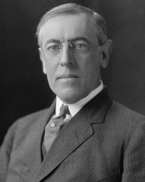
1.3.1 Summarize Wilson’s Fourteen Points.
Woodrow Wilson of U.S.A- No more secret agreements ("Open covenants openly arrived at").
- Free navigation of all seas.
- Removal of economic barriers between nations.
- Countries were to reduce armaments to no more than what was needed for domestic security
- Decisions regarding the colonies should be made by impartial arbitrators in the interest of the colonies
- German Army to withdraw from Russia and Russia left to determine her own political future
- Belgium should be independent like before the war.

1.3.2 Analyze French and British objectives at the Paris Peace Conference.
Georges Clemenceau (French Premier) wanted to punish Germany and limit their power to make war in the future.
France had two basic goals:
1. National Security
- a weak Germany would ensure security.
- demanded return of Alsace-Lorraine.
- demanded that they receive the German Rhineland to serve as a buffer zone between Germany and France.

2. Financial Reparations
- Clemenceau demanded that Germany pay full reparations for war damages with no time limit being placed on how long they would have to repay the amount owed.
- Key concern was security of sea lanes to its empire (this meant German sea power had to be crippled).
- Lloyd George (British Prime Minister) was concerned that a harsh treaty might lead Germany to wanting revenge in the future (another war). He tried to work out a compromise of the French demands.
- Also feared the spread of Bolshevism (Communism) into Europe from Russia. If Germany was weakened too much it could fall into the hands of Communist Russia.
- Britain’s position was somewhat “softer” on Germany than was France’s.

1.3.3 Summarize the main terms of the Treaty of Versailles.
Germany had to pay Reparations for the damages done by the war
Germany to return the provinces of Alsace and Lorraine to France
Germany had to turn over resources from the Saar Basin until reparations were paid
Germany was to be forever limited to no more than 100 000 soldiers in its Military
Germany could not have an air force
Germany's navy was limited to small ships only
Germany could not place troops in the Rhineland (Germany land near French border)
Germany could never again unite with Austria
Germany had to take full responsibility for World War I (War Guilt Clause) This was the worst of all the terms of the treaty for the German people! They were forced to accept responsibility for starting the war. They could almost deal with most of the clauses but this drove them over the edge.

Peace Conference 1919
The allies who won the war needed to decide on how to proceed now that the war was over. Nations had to be re-established, damages had to be repaired and responsibility for it all had to be assigned to someone.
January 18th 1919, a peace conference was held in Paris. This was previously agreed upon during the armistice signing in November 1918. The reason for this conference was to decide upon post-war Europe. The big three, the three leaders holding this peace conference were: Woodrow Wilson of the United States, David Lloyd George of Great Britain and Georges Clemenceau of France. They, along with representatives or diplomats of 32 different allied nations met to discuss the fate of the world. Only the 3 governments mentioned above could make final decisions. The defeated nations were not permitted to have representation at this conference. Germany and Russia were among the nations forbidden from attending.
Why did the peace process have an air of defeat right from the beginning?
1. The defeated nations were not allowed access to the conference for PEACE. (Ironic hey?)
2. The new communist government in Russia was refused participation
3. The deciding power rested with only 3 countries; GB, France and U.S. Basically, their idea was: this is how we decide peace will go…ok? Objections? Good! Don’t bother anyway!
From this conference came the agreement or the Treaty of Versailles which definitively ended WW1 on the 28th of June 1919.
The main objectives of the Big 3 at the peace conference in Paris:
United States:
• They were determined to establish a new world order based on Wilson’s 14 points.
• Resume commercial trade so as to prosper once again.
• Assure that Great Britain and France pay back their loans given during the war.
France: (what is to be most of all remembered is that they wanted some organisation to monitor threat- national security and financial reparations)
• World Security. The threat of German military power be abolished.
• Alsace-Lorraine be returned to them (fairly won during a quest dating pre-WW1)
• They wanted rights to the Rhineland-an important military training area for Germany.
• Instead they settled upon the Rhineland becoming a demilitarized zone whereby Germany and her army was forbidden from entering.
• Compensation for damages caused by war.
• The leaders of this conference decided upon 30 billion dollars being the sum of compensation that Germany would have to pay for all damages and that France receive 52% of that amount.

Great Britain:
• They wanted to ensure security of the sea lanes to its empire. (Prohibiting German submarines and heavily reducing its navy)
• Germany’s acquired colonies were to be redistributed amongst the allies.
• George did believe however that if all that compensation be forced upon Germany then their country could fall into the hands of communism-having an economy so crippled. Both George and his colleague, Winston Churchill believed that they as a whole should lighten the load of the 30 billion dollar reparations clause. (as they saw happen in Russia)

1.3.4 Draw conclusions about whether or not the Treaty of Versailles was a just peace treaty.
If you say, 'Yes, Treaty of Versailles was fair'
Germany should be punished since it was the major aggressor. They declared war first. They invaded a neutral nation to begin this conflict and should be expected to pay reparations.
They launched an unprovoked attack on France…. France should expect to be compensated for damages and assured of its future security.
Germany gave its full support for the Austro-Hungarian ultimatum. Without this support, the Balkan conflict may have simply been a localized affair.
Germany was bent on achieving a colonial empire and was acting aggressively towards other nations. They needed to be reined in.

If you say, 'No, Treaty of Versailles was not fair'
Other countries should accept some degree of responsibility for starting this conflict. It shouldn’t be only Germany that should accept blame and be expected to pay damages.
- Austria-Hungary was the nation that delivered the ultimatum to Serbia. An ultimatum that Serbia could not accept.
- Russia began mobilizing troops almost immediately in spite of appeals from Germany to stop the process.
- France wanted a war to weaken Germany. Should Germany therefore be expected to give up control of its resources and pay for the restoration of France?
- Britain wanted to destroy the German navy. Was it fair to take their merchant marine fleet as well as their military ships and submarines?
- Germany did not provoke or play any role in the assassination that ignited this conflict.
Is it reasonable to impose such harsh terms on Germany’s people when it was their government that was responsible for the military action that was taken? Was it right to impoverish the German people? Would another punishment be more appropriate?
NOTE: When all things are considered, the fault of the war can be traced back to those ideologies of Imperialism, Militarism, Nationalism and the alliance System. The smart kids will always point this out.

1.3.5 Explain the purpose for creating the League of Nations.
The League was designed to be an international arbitrator of disputes.
It provided nations with a forum to discuss disputes and it gave them an organization through which collective action could be taken to pressure nations into peacefully resolving problems.
Sanctions could be used to pressure governments to act as the League wished.
The U.S. did not join the League – this served to limit its effectiveness as an organization.
THE LEAGUE OF NATIONS' PURPOSE WAS TO PROMOTE INTERNATIONAL PEACE AND SECURITY!

1.3.6 Predict what impact the Versailles Treaty might have on Germany and European stability during the post-war period.
Germany Following Treaty of Versailles
Following the end of World War I Germany set up a democratic form of government, this government was referred to as the Weimar Republic. The Weimar Republic faced many problems as a result of the Treaty of Versailles and weaknesses in the new constitution*.German attitudes towards Treaty: German's called it a dictated peace because they no say in the making of the Treaty Germans felt the military terms left their country vulnerable to invasion by neighbouring countries. The "War Guilt Clause" was seen as unfair as most Germans did not feel they were responsible for causing the war. Germans resented paying huge amounts of reparations to countries they feel shared the blame for the war. Germans felt the Treaty would be based on Wilson's 14 Points, especially national self- determination, yet Germans found themselves ruled by
Danes, Poles and Czechs. Germany felt it would be a full member of the League of Nations however it was refused membership.

Impact of the Treaty:
Politically - The new Weimar Republic was forced to sign the Treaty. As a result Germans always associated the new Democratic government with the humiliating treaty. Often this government were referred to as the November Criminals" (armistice was signed in Nov.) and accused of stabbing the army in the back. The Weimar Republics association with the Versailles Treaty was always used against it by its enemies (Hitler). Extremists were determined to overthrow the Republic.
Economically - The 1919 Treaty of Versailles and the 1921 London Schedule of Payments required Germany to pay 132 billion gold marks or $33 billion U.S in order to cover civilian damage caused during the war. Germany could not afford these Reparations payments. The country was economically exhausted. Regions that could make money such as the Saar coalfields had been taken. By 1923 Germany fell behind in reparation payments. French and Belgian troops invaded Germany's industrial heart the Ruhr and took the goods they needed. To deal with economic problems the German government began printing so much money to pay its bills that German money became worthless (Hyperinflation). 1923 Hitler will try to take over with a military coup & fail.
1924 - 1929 Weimar Republic gets loan from U.S. and gets reparation payments lowered however unemployment remains a serious problem. Stock market crash of 1929 results in withdrawal of U.S money which devastates the German economy.
One time on the public exam they showed a cartoon of a child crying. The child was labelled Germany and the leaders of the Allied Powers were standing next to it. They asked about what the impact of the Treaty of Versailles was on Germany after World War I. Here's a decent answer to that question:
Following World War I, the Allied Powers put in place a treaty known as the Treaty of Versailles. This agreement signed in 1919, imposed some harsh conditions on Germany. First of all it insisted that Germany was 100% responsible for the war (War Guilt Clause). This meant that Germany had to pay reparations of around $33 billion American. They were also forbidden to have an air force, large ships in its navy, or more than 100,000 soldiers in their army. They weren't allowed to put troops in the Rhineland, even though they owned the Rhineland. They had to give Alsace and Lorraine back to France and they had to turn over all their coal and iron until the reparation payments were done. The result was that the German economy was ruined and its people were starving. They were already devastated by the War, but these terms left them with huge unemployment and a worthless currency. They made an effort to establish a democratic system with the Weimar Republic, but one government after another fell because of its inability to get the country back on its feet. The source is showing us how this new Germany is crying because of the terms imposed by the leaders of the Allied Powers. The leaders of Britain and France and Italy and the U.S. are hearing the child crying. The child is the class of 1939 which is the year World War II starts. The restrictions of the Treaty of Versailles left Germany in such a desperate state that it opened the door for an extremist like Hitler to come in and put the whole world back to war again.

