World History 3201 - Unit 03

Notes on the SCOs
3.1 The student will be expected to draw upon primary and/or secondary sources to demonstrate an understanding of the causes of World War II,

3.1.1 Define:
Pan-Germanism,
German nationalist doctrine aiming at the union of all German-speaking peoples under German rule. Pan-Germanists were especially interested in the German groups in neighbouring countries, such as Austria, Czechoslovakia, Poland, Switzerland, and Alsace.
Lebensraum (“living space”)
A German Expression that means living space. It was Hitler's ambition of taking land in Europe to create more living space for Germans.
Anschluss
the union of Germany and Austria.
Sudetenland
Region along the western border of Czechoslovakia - the border it shares with Germany - where a majority of citizens speak German.
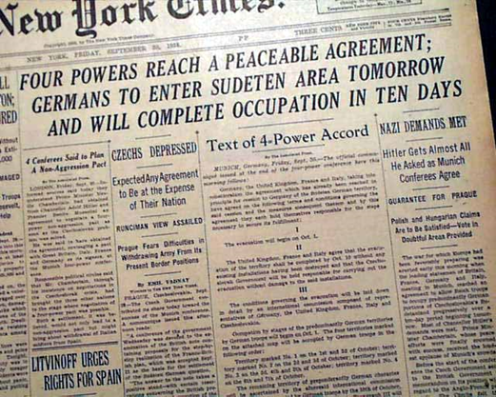
Munich
an act of appeasement that allowed Germany to take over the Sudetenland region of Czechoslovakia.
The agreement was reached in September 1938 between Britain, Germany, France and Italy. Germany was given the Sudetenland in Czechoslovakia in exchange for a promise of no further territorial aggression. British Prime Minister Neville Chamberlain announced that the pact secured “peace in our time”.
Czechoslovakia had not been invited to the conference.
Hitler broke the promise. By March 1939 he'd taken all of Czechoslovakia

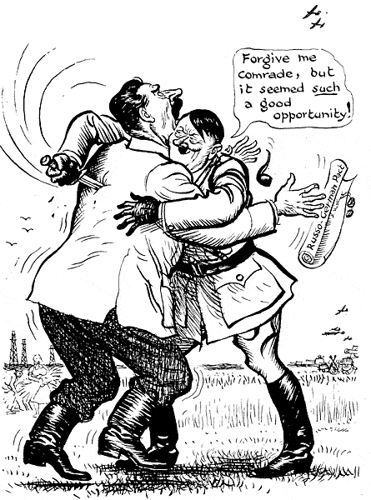
Nazi-Soviet Pact
August, 1939 agreement between Germany and Soviet Union where each promised not to wage war against the other. Secretly they agreed to divide Poland when Germany conquered it.
* this agreement also called the non-agression pact shocked the world
* this agreement meant that germany would not have to fight a two front war.
* in essence it only delayed the inevitable clash between these bitter enemies, the editorial cartoon illustrates Hitler’s violation of this pact.

3.1.2 Identify the two main military alliances of World War II and list three key members of each.
The Allied Powers
• The United States
• The Soviet Union
• Britain

The Axis Powers
• Germany
• Italy
• Japan

3.1.3 Analyze the League of Nation’s effectiveness in dealing with threats to world peace with reference to:
Japanese occupation of Manchuria 1931-1932
One of the most important political issues following WWI was how to keep world peace. Most European nations maintained a nationalist point of view, arguing that they could pursue and protect their own national security through their own military power or by alliances. Following WWI Woodrow Wilson’s idealism spurred many nations to adopt the idea of global collective security. The basic idea that peace was a responsibility of all nations. Security for individual nations would be achieved through group solidarity. In theory no nation would attack another for fear of being punished by sanctions. The sanctions included:

• Moral Sanctions: World opinion would be used to encourage nations to behave properly.
• Economic Sanctions: In theory nations who threatened international security would be cut off from trade by other nations.
• Military Sanctions: Involved the restricting of exporting weapons & other military technology to aggressive nations.

All of this would be carried out by the newly formed League of Nations (1920 - 1946).

Effectiveness of the League of Nations

After the League was formed in 1920 it was faced with solving international disputes and experienced some minor successes. However without powerful nations such as the U.S. and USSR it was difficult to control international aggression.
Italian invasion of Ethiopia 1935
Italian invasion of Ethiopia/Abyssinia 1935: Part of Mussolini’s dream of rebuilding the Roman Empire involved capturing land in Africa. He settled on Ethiopia. In 1935 Italian forces with modern tanks invaded Ethiopia which was armed with old weapons and spears. Much of the world was outraged. Ethiopian Emperor Haile Selassie begged the League for help. The League threatened economic sanctions against Italy. When Mussolini threatened war if economic sanctions on oil were imposed. The League backed down. Later Mussolini admitted, “ If the League had extended economic sanctions to oil, I would have had to withdraw from Ethiopia within a week.”

German rearmament 1935
Germany’s rearmament in 1935 The League also failed to stop Germany’s rearmament in 1935, and occupation of the Rhineland in 1936.

German occupation of the Rhineland 1936
Hitler sent his troops into the Rhineland and that was a violation of the Treaty of Versailles. Everyone expected France and Britain to retaliate but they didn't. They just tried to appease him again.

Japanese all-out war against China 1937
Japanese occupation of Manchuria 1931: Manchuria in northern China was rich in minerals that Japan wanted. Japanese troops guarding the South Manchurian Railway) alleged that Chinese saboteurs attempted to blow up a section of the railway. Claiming they were protecting the railway Japan captured all the main cities of Manchuria. Chinese leader Chiang Kai-shek asked the League for help. In 1933 after a lengthy investigation the League condemned Japan and recommended that it withdraw from Manchuria. Japan ignored the League and simply withdrew. WHY ?

Japan’s war with China in 1937 The League also failed to stop Japan’s allout war against China in 1937.
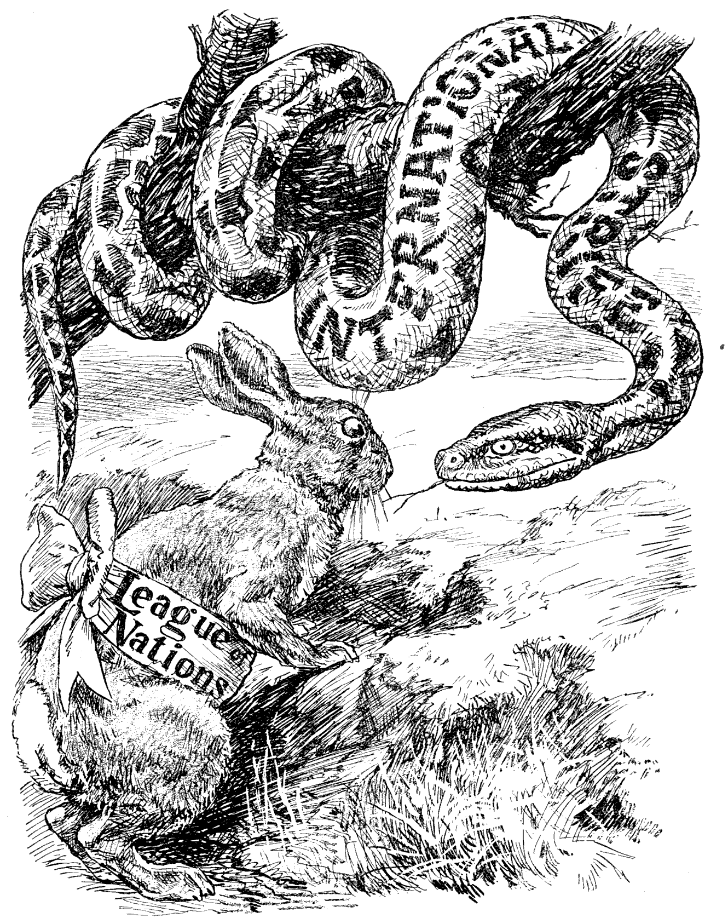
Conclusion: as illustrated in the editorial cartoon, the LON was never truly effective as a peace keeping organization, the lasting importance of the League lies in the fact that it provided the groundwork for the United Nations. This international organization formed after WWII learned from the mistakes of the League.

3.1.4 Analyze reasons for German expansion during the late 1930s.
Hitler’s goal of German expansion in the 1930's was based on his goal to establish Germany as the dominant power in Europe. To accomplish this goal he needed to expand Germany for two reasons:

1. Hitler wanted to make Germany self-sufficient. Trade was not the answer because that would make Germany dependent on others which would weaken Germany during times of war. Thus Germany would have to expand in order to obtain rich agricultural land and other valuable resources.

2. Hitler believed that Germany needed more lebensraum (living space) for its expanding Aryan population. Hitler encouraged an increased birth rate among Germans (future scientists, engineers, soldiers). Thus Germany needed to expand to accommodate its population.

3.1.5 Describe the policy of appeasement as it is related to German expansion and identify two reasons why Britain and France were prepared to follow this policy.
France and Britain appeased Germany for a variety of reason during the 1930's

1. In the 1930's the slaughter of a whole generation of young men in WWI was still fresh in the memories of most Europeans. As a result most leaders wanted to avoid a repetition of such bloodshed and war.

2. The Western world was caught in the grip of the Great Depression. Most countries lacked the money to take care of their unemployed citizens. Rearmament and war preparations would only make matters worse.

3. Many right wing people Britain and France feared the growth of Communism. To them the strong anti-communist rantings of Hitler and Mussolini were a counter force to the spread of communism.
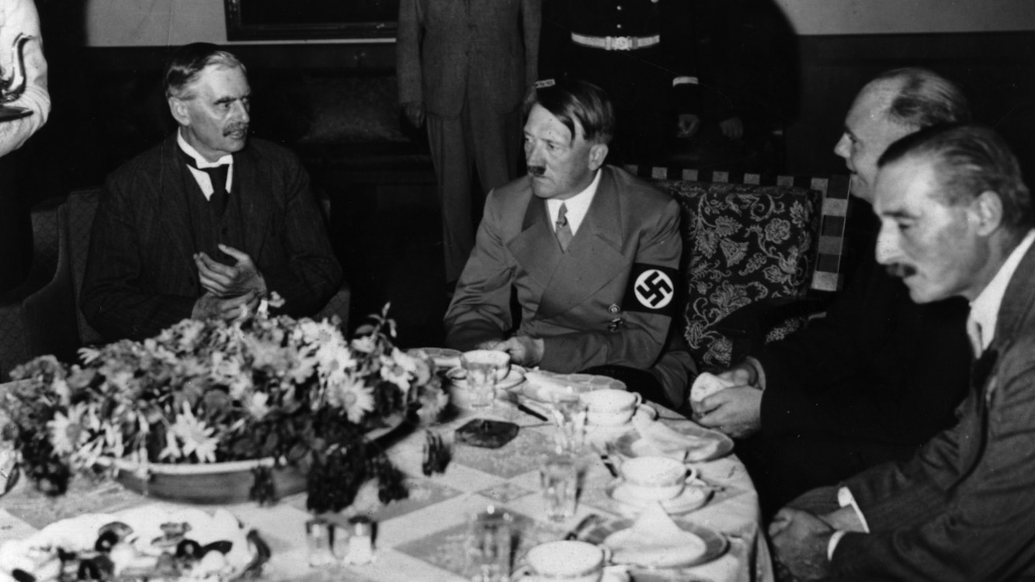

Hitler is Appeased:
1. 1935: Hitler begins rearming Germany (increasing its army, navy and creating an air force known as the Luftwaffe)
2. March 1936 : Hitler moves the German army into the Rhineland and reclaims it for Germany.
3. March 1938 : Hitler moves to unite Germany and Austria (Anschluss). Under threat of German military action the Austrian Chancellor resigns and appoints the leader of the Austrian Nazi party in his place. The nazi leader invites Hitler to send in German troops to restore order by the next day Austria is part of Germany.

3.1.6 Evaluate the effectiveness of appeasement in containing the territorial expansion of Nazism.
All 3 acts violate the Versailles Treaty but France and Britain do nothing due to the reasons stated earlier. Though each time Hitler is successful he becomes more powerful and bold.

The Failure of Appeasement: September 1938: Hitler encourages German speaking people in the Sudenten region of Czechoslovakia to demand self- government. When Czech. refuses Hitler plans an invasion. Before Hitler attacks British Prime Minister Neville Chamberlain and French Premier Edouard Daladier pressure Czech. To give this region to Hitler in order to avoid war. At the
Munich Conference in Sept. 1938, Hitler, Chamberlain, Daladier, and Mussolini sign the Munich Pact, giving Germany the Sudentenland in return for Hitler’s promise to make no more territorial demands.

Chamberlain returns to England stating “I believe it (Munich Pact) is peace for our time”. Other leaders such as Winston Churchill feel appeasement only delays the inevitable (war).

March 1939: Hitler breaks his promise in the Munich Pact and takes over the rest of Czechoslovakia .

Appeasement has failed, Britain and France realizing Hitler has fooled (his word could never be trusted) them pledge to support Poland, and warn that an invasion of Poland will mean war.

3.1.7 Analyze documents to compare Winston Churchill’s views on appeasement with those of Neville Chamberlain.

“We must always demand so much that we can never be satisfied.”
- Hitler on his strategy at Munic -
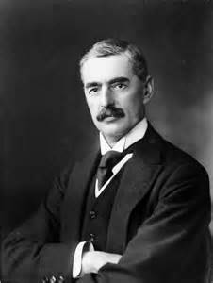
“In spite of the hardness and ruthlessness I thought I saw in his [Hitler’s] face, I got the impression that here was a man who could be relied upon when he had given his word.”
-Neville Chamberlain, prior to the Munich Conference-

"We, (Hitler & Chamberlain) are resolved that consultation (discussion) shall be the method our two countries use to deal with differences so that we may ensure the pace of Europe."
-Neville Chamberlain, 1938-
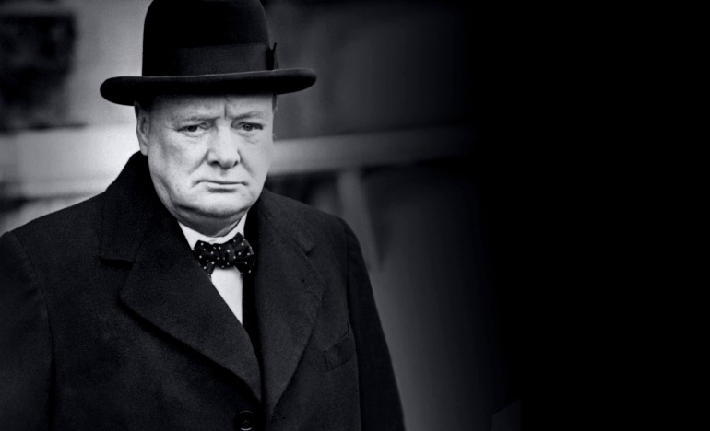

“England has been offered a choice between war and shame. She has chosen shame and will get war.”
-Winston Churchill, September 1938-

“An appeaser is one who feeds a crocodile, hoping it will eat him last “
-Winston Churchill-

3.1.8 Explain why Britain and France ended appeasement with Hitler’s demands on Poland.
Hitler’s success in foreign policy encouraged him to take another gamble and go for Poland. The dispute was over Danzig and the Polish Corridor both of which had belonged to Germany prior to 1919. The predominant German population of the Polish Corridor pushed to be reunited with Germany. Hitler ordered his generals to prepare invasion plans.
Could he win these areas through bluff again like he had Czechoslovakia?
This time the British and French realizing they had been fooled at Munich, no longer trusted Hitler and pledged to support Poland. It was a warning that further expansion would be opposed.

3.2 The student will be expected to draw upon primary and/or secondary sources to demonstrate an understanding of the events of World War II.

3.2.1 Define:
Blitzkrieg: German term for “lightning war”. The use of swift massive strikes from the air coupled with rapid tank invasions on the ground.
Phoney war: period of time from Oct. 1939 to April 1940 when there was a lull in fighting.
Maginot Line: elaborate set of defensive fortifications, built by the French, along the French German border.
Kamikazes: The suicide missions of Japanese air force pilots who crashed their aircraft into enemy targets during World war II.

3.2.2 Assess the early success of Germany in the first year of World War II.
German Successes Early in WWII
Poland was pleased tom learn that France and Britain would help defend Poland against German attack. Germany could now be defeated. Within 4 weeks Poland was crushed at the cost of just 8000 German dead. The British and French had hardly fired a shot.
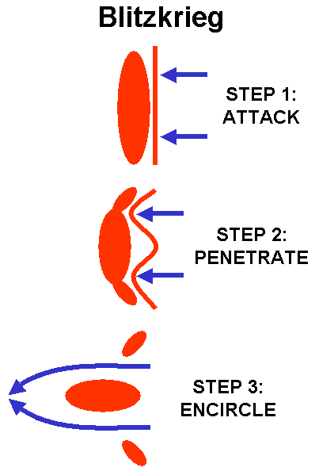
What happened?
The answer is Blitzkrieg. The principle behind this strategy was that the best way to defeat an enemy is to throw a massive assault against the enemies weakest point and cut them off from all supplies and communication.
This was achieved by:
First enemy headquarters and communications were bombed by artillery and bombers. Parachutists dropped behind enemy lines to cause panic.
Second tanks and infantry punch a hole in the weakest part of the enemy front line encircling enemy strong points.
Third troops following up cut the enemy off from reinforcements thus forcing surrender.

3.2.3 Analyze two reasons why Britain was able to survive the Battle of Britain.
Radar
Royal Air Force
Hitler's change of Strategy

3.2.4 Describe the impact of the following key battles on the outcome of World War II:
Dunkirk evacuation
On May 20 German troops on the invasion of France began to push north along the coast. By May 26, the British and French were pushed into a narrow beachhead around Dunkirk. The Belgian king, Leopold III, surrendered his army the next day. Destroyers and smaller craft of all kinds rescued 338,226 men from Dunkirk in a heroic sea lift that probably would not have succeeded if the German Commander, General Gerd von Rundstedt, had not stopped the tanks to save them for the next phase of the War.

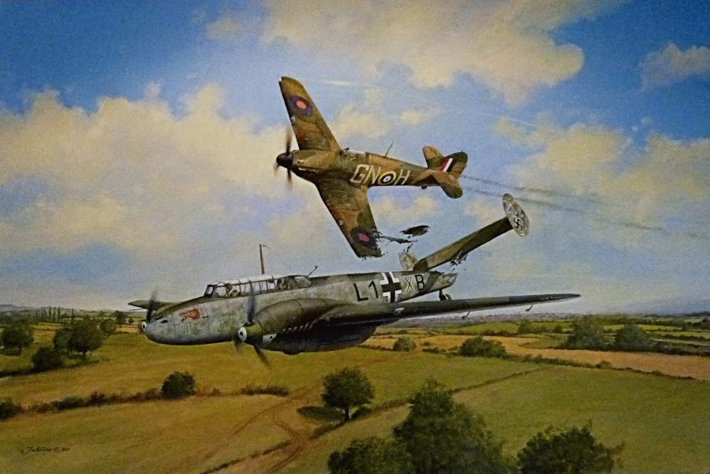
Battle of Britain
In the summer of 1940, Hitler dominated Europe his one remaining active enemy—Britain, under a new prime minister, Winston Churchill—vowed to continue fighting. Whether it could was questionable. The British army had left most of its weapons on the beaches of Dunkirk. The Germans hoped to defeat the British by starving them out. In June 1940 they undertook the Battle of the Atlantic, using submarine warfare to cut the British overseas lifelines. Invasion was the quick way to finish off Britain, but that meant crossing the English Channel; Hitler would not risk it unless the British air force could be neutralized first.
As a result, the Battle of Britain was fought in the air, not on the beaches. In August 1940 the Germans launched daylight raids against ports and airfields and in September against inland cities. The objective was to draw out the British fighters and destroy them. The Germans failed to reckon with a new device, radar, which greatly increased the British fighters' effectiveness. Because their own losses were too high, the Germans had to switch to night bombing at the end of September. Between then and May 1941 they made 71 major raids on London and 56 on other cities, but the damage they wrought was too indiscriminate to be militarily decisive. On September 17, 1940, Hitler postponed the invasion indefinitely, thereby conceding defeat in the Battle of Britain.

Operation Barbarossa
Germany invaded the USSR on June 22, 194,with more than 3 million troops. The Soviet army had 2.9 million troops on the western border and outnumbered the Germans by two to one in tanks and by two or three to one in aircraft. German Success Hitler and his generals had agreed that their main problem was to lock the Soviet army in battle and defeat it before it could escape into the depths of the country. To Hitler, the land and resources of the Ukraine and the oil of the Caucasus were most important. German plans indicated a victory in about ten weeks, which was significant because the Russian summer was the ideal time for fighting in the USSR.Churchill offered the USSR an alliance, and Roosevelt promised lend-lease aid, but after the first few days, both believed everything would be over in a month or so. By the end of the first week in July Germany had 290,000 prisoners and by August 5, having crossed the Dnieper River, the last natural barrier west of Moscow they had another 300,000 Russian prisoners. On reaching Smolensk, the German army had covered more than two-thirds of the distance to Moscow.
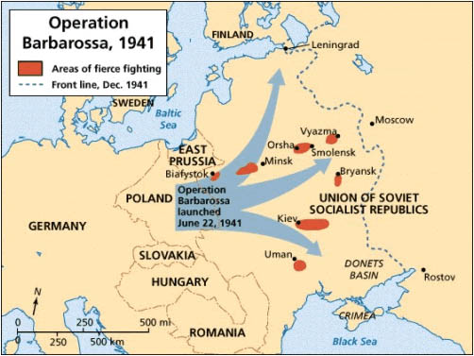
Hitler’s Change of Plan
Russia was doing exactly what the German generals had wanted, sacrificing enormous numbers of troops and weapons to defend Moscow. Hitler, however, was not satisfied, and over the generals' protests, he ordered Army Group Centre to divert the bulk of its armour to the north and south to help the other two army groups attacking Stalingrad and Leningrad, thereby stopping the advance toward Moscow. On September 8 German Army Group North cut Leningrad's land connections and, together with the Finnish army brought the city under siege. On September 16 Army Group South closed a gigantic encirclement east of Kiev that brought in 665,000 prisoners. Hitler then decided to resume the advance toward Moscow and ordered the armour be returned to Army Group Centre.

The Attempt to Take Moscow
After a standstill of six weeks, Army Group Centre resumed action on October 2. Within two weeks, it completed three large encirclements and took 663,000 prisoners. Then the fall rains set in, turning the unpaved Russian roads to mud and stopping the advance for the better part of a month. In mid-November, the weather turned cold and the ground froze. Hitler and the commander of Army Group Centre, Field Marshal Fedor von Bock, faced the choice of having the armies dig in where they were or sending them ahead.
Wanting to finish the 1941 campaign with some sort of a victory at Moscow, they chose to move ahead. In the second half of November Bock aimed two armoured spearheads at Moscow. Just after the turn of the month, one of those, bearing in on the city from the northwest, was less than 32 km away. The other, coming from the south, had about 65 km still to go. The panzer divisions often covered such distances in less than a day, but the temperature was falling and neither the men nor the machines were outfitted for extreme cold. On December 5 the generals commanding the spearhead armies reported that they were stopped: The tanks and trucks were freezing up, and the troops were losing their will to fight.

Counter Offensive
Stalin, who had stayed in Moscow, and his commander at the front, General Zhukov, had held back their reserves. Many of them were recent recruits, but some were hardened veterans. All were dressed for winter. On December 6 They counterattacked, and within a few days, the German spearheads were rolling back and abandoning large numbers of vehicles and weapons, rendered useless by the cold. On Stalin's orders, the counterattack quickly became a counteroffensive on the entire front. The Germans had not built any defense lines to the rear and could not dig in because the ground was frozen hard as concrete. Some of the generals recommended retreating to Poland, but on December 18 Hitler ordered the troops to stand fast wherever they were. Thereafter, the Russians chopped great chunks out of the German front, but enough of it survived the winter to maintain the siege of Leningrad, continue the threat to Moscow, and keep the western Ukraine in German hands.

Battle of El Alamein
Italian forces and the Nazi Afrika Korps entered Egypt in a drive for the Suez Canal in June 1942. The British 8th Army held fast at El Alamein, about 60 miles southwest of Alexandria. On October 23 British infantry cut through the Axis lines in a bayonet charge that opened the way for an armoured breakthrough. The attack forced the Axis back 1,300 miles across the desert.

Battle of Stalingrad
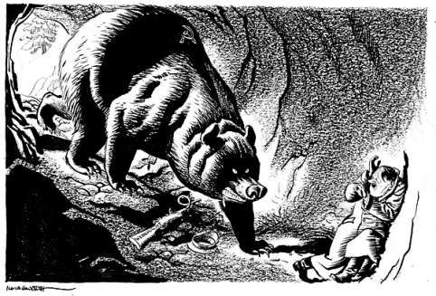
On July 28 Stalin issued his most famous order of the war, “Not a step back!” While threatening severe punishment for defeatists, he called on the troops to fight a “patriotic” war for Russia.. In late August he called on his two best Generals Vasilyevsky and Zhuchov to deal with the situation at Stalingrad. They proposed to wear the enemy down by locking its troops in a bloody fight for the city while they assembled the means for a counterattack. The German advances to Stalingrad and into the Caucasus had added about 1100 km to their line. No German troops were available to hold that extra distance, so Hitler had to use troops contributed by his allies Romania, Italy and a Hungary Serious weaknesses existed in these armies. On the morning of November 19, in snow and fog, Soviet army hit the Romanians west and south of Stalingrad. Within three days the Soviets had encircled most of the German Sixth Army, about half of the Fourth Panzer Army, and a number of Romanian units. Hitler ordered the Sixth Army to hold the pocket and promised air support which never arrived. The Sixth Army was doomed if it did not attempt a breakout, which Hitler refused to permit. The Russians pushed in on the pocket from three sides in January 1943, and the head of the Sixth army General Paulus surrendered on January 31. The battle cost Germany about 200,000 troops. In the aftermath of Stalingrad the Germans were forced to retreat from the Caucasus and back approximately to the line from which they had started the 1942 summer offensive.

Battle of the Atlantic:
The Battle of the Atlantic was Canada's longest military engagement of the Second World War, lasting from September 1939 to May 1945. This battle was fought by the men and women of the Canadian Merchant Navy, the Royal Canadian Navy and the Royal Canadian Air Force. More than 4,600 service men and women lost their lives at sea.

Battles of Midway and Coral Sea
Midway was a decisive naval engagement of World War II, which gave the United States sea power over the Japanese. It was fought in June 1942 near the Midway Islands by Japanese and U.S. aircraft carriers. The victory at Midway terminated a major Japanese attempt to capture the islands as a possible prelude to an invasion of Hawaii. The success of the operation, only a month after the important but indecisive Battle of the Coral Sea, effectively tipped the balance of sea power in the Pacific Ocean in favor of the United States.

The Battle of Coral Sea
Coral Sea major naval and air engagement of World War II, fought by American and Japanese forces. The battle marked a turning point in the war because it effectively checked the Japanese advance to the south. The Japanese, already in command of a vast area in the Pacific region, were looking to Australia as their next conquest and were trying to move into position for an invasion. A Japanese offensive to this effect was begun on May 4 with the seizure by one Japanese naval force of the port of Tulaghi in the Solomon Islands, while a second and larger force steamed southeast of New Guinea. Two American task forces joined to oppose the Japanese moves. On May 4, American carrier-based bombers and torpedo planes inflicted severe damage on the Japanese vessels at Tulaghi. The American fleet then moved to intercept the second Japanese naval force. American carrier-based planes caused the Japanese to retire with heavy losses, making this engagement the first naval battle in history in which ships of both sides did not encounter one another directly.

Normandy invasion (D-Day)
Normandy Invasion (D-Day) On June 6, 1944, D-Day, the U.S. First Army and the British Second Army established beachheads in Normandy, on the French channel coast. The German resistance was strong, and the footholds for Allied armies were not nearly as good as they had expected. Nevertheless, the powerful counterattack with which Hitler had proposed to throw the Allies off the beaches did not materialize, neither on D-Day nor later. Enormous Allied air superiority
Over northern France made it difficult for Rommel, who was in command on the scene, to move his limited reserves. Moreover, Hitler became convinced that the Normandy landings were a feint and the main assault would come north of the Seine River. Consequently, he refused to release the divisions he had there and insisted on drawing in reinforcements from more distant areas. By the end of June, Eisenhower had 850,000 men and 150,000 vehicles ashore in Normandy
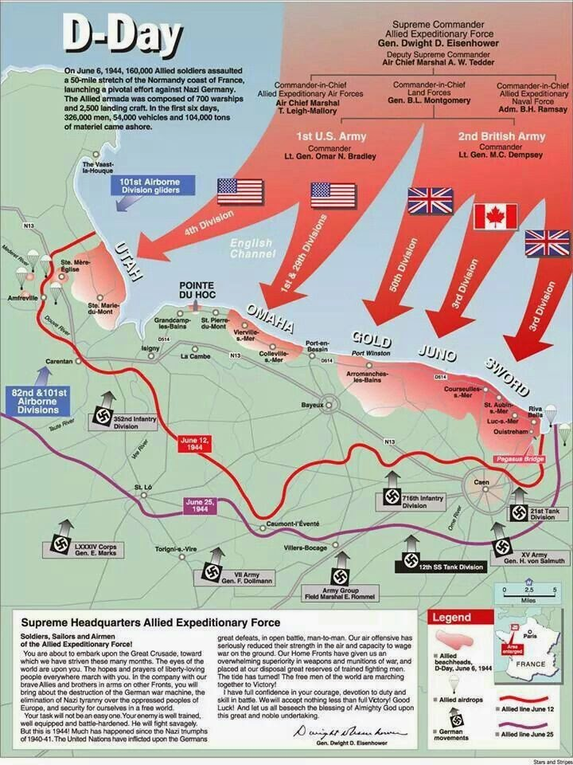
3.2.5 Explain how the stationing of the American Pacific fleet in Pearl Harbour and American economic sanctions against Japan strained Japanese-American relations prior to the attack on Pearl Harbour.

In the summer of 1937 Japan attacked and soon occupied most of China. The League of Nations condemned Japan but took no action. So in 1939 the United States imposed economic sanctions (stopped trading) which seriously affected Japanese industries that depended on American petroleum, steel, iron and industrial machinery. In 1940 Japan occupied part of Indochina. The United States warned Japan against further aggression and reinforced these warnings by stationing its Pacific Fleet in Pearl Harbor, Hawaii. In 1941 U.S. President Roosevelt imposed further economic sanctions on aviation fuel, iron and scrap metal. In July 1941, Japan responded to these sanctions by announcing the Greater East Asia Co-Prosperity Sphere which called for Japanese control of all resources in Southeast Asia. Roosevelt responded in July freezing all Japanese assets in the U.S. and by ending all trade between the U.S. and Japan. Relations between the two countries was at an all time low. Japanese leaders faced the choice: to negotiate or fight. Japan choose to fight and began plans for an attack at Pearl Harbor.

3.2.6 Describe how each of the following factors contributed to American military success over Japan.
size of American fleet
more advanced technology and greater industrial strength
Japan had hoped that the attack at Pearl Harbor would be the first step in developing an empire in Asia, however the U.S. quickly recovered. Within a year American industry had all the damaged vessels back in service fighting against the Japanese. The size of the American fleet and the number of personnel, combined with more advanced technology and a faster rate of production, helped the Americans drive the Japanese from their possessions in he Pacific.

3.2.7 Draw conclusions about how the American entry into world War II affected the war’s outcome.
3.2.8 Judge whether or not the dropping of atomic bombs on Japan was justified.

Hiroshima - August 6, 1945: Atomic bomb destroyed 90% of the city and killed an Estimated 80,000 citizens instantly. Tens of thousands more would die later.

Nagasaki - August 9, 1945: Atomic bomb killed 40,000 citizens instantly. Tens of Thousands more to die later.

There are two perspectives on the use of the Atomic Bomb:

In justification of using the Atomic Bomb:
America had been at war with Japan since December 1941, when Japan had viciously attacked the American base at Pearl Harbor. That attack had been unprovoked, and devastating. The memory of this attack, and the stories of how the Japanese were treating American prisoners of war caused Many to believe retaliation with atomic bombs was justified.
The Japanese followed what some called the 'Samarai' tradition. The idea that surrender was unthinkable, and that citizens should kill themselves in defense of their country. The result was that Japanese defense of Pacific islands was fierce - suicide attacks by individuals were common. Not only by soldiers, but by civilians as well. This is further evidenced by the kamikaze attacks on American ships - the practice of volunteer pilots flying their planes filled with explosives directly into American ships. Experts suggested that an assault on the main island of japan might result in the death of as many as 250,000 American soldiers along with countless Japanese. If the atomic bomb could prevent the need for such an invasion, it would be well justified.
To this point in the war the Japanese 'War Party' or governing body had rejected all peace terms. They continued to vow that the Japanese would fight to the bitter end, and fight in such a way that America would be demoralized by casualties. The implication was that the war could drag on indefinitely as America attempted to subdue such defiance. The use of the atomic bomb would be justified if it could bring the war to a timely end - if it could cut short the horror and devastation of the war.
It's true that hundreds of thousands of people were killed or worse by the effects of the atomic bomb, but we must remember that the damage caused by conventional weapons far exceeded that - some say by as many as 10 times. At the end of the day, while the 80,000 casualties of Hiroshima and the 40,000 of Nagasaki are the tragic beyond words, their deaths may have saved the lives of countless more, because within days of the bombing of Nagasaki, Japan surrendered.

In support of the idea that the use of the atomic bomb cannot be justified:
THERE ARE A GREAT MANY PEOPLE WHO ARE DUBIOUS ABOUT THE IDEA THAT THE ATOMIC BOMB WAS NECESSARY AT ALL. TO BEGIN WITH, IN THE SUMMER OF 1945 JAPAN WAS RUINED. IT HAD NO ALLIES LEFT - ITALY AND GERMANY WERE OUT OF THE WAR. IT HAD ALL BUT LOST THE NAVAL WAR IN THE PACIFIC - TO THE POINT THAT IT COULD NO LONGER IMPORT RAW MATERIALS, food AND OIL INTO THE MAIN ISLAND OF JAPAN. IT HAD LOST THE VAST MAJORITY OF ITS INDUSTRIAL CAPACITY - CONSIDER THE FIRE BOMBING OF TOKYO AND OTHER MAJOR JAPANESE CITIES. THE RESULT WAS THAT JAPAN WAS ON THE VERGE OF SURRENDER ANYWAY. There are some suggestions that many Japanese would have starved that winter. AMERICA HAD ONLY TO WAIT A BIT. THERE WAS NO NEED TO UNLEASH SUCH A DEVASTATING WEAPON, OR EVEN TALK OF WHAT CASUALTIES WOULD BE LOST IN AN INVASION. THEY ONLY NEEDED TO WAIT, AND JAPAN WOULD have had to GIVE UP.

The idea that the Japanese fighting spirit, their unwillingness to surrender, but rather die for their country, reflects some sort of insanity or madness in them is unfair. in fact there are a great many stories of Canadian and British soldiers who threw themselves on hand grenades in the trenches of WW I in an effort to save their comrades. In the Battle of Britain, there are stories of British fighter pilots who flew their planes into the German bombers to prevent them from bombing London. Yet these are examples of heroes to us. Why is it they are heroes but the Japanese who were willing to give their lives for their country are crazy people? The truth of the matter is that there was a growing sentiment in Japan that surrender was preferable to annihilation of the entire population. In fact America, and General MacArthur in particular, had received a number of Japanese peace proposals. All of them conditional, but peace proposals none the less.

THE EFFECTS OF THE ATOMIC BOMB WERE HORRIFIC. IT IS NOT ENOUGH TO TALK OF THE 80,000 THAT DIED INSTANTLY IN HIROSHIMA, OR THE 40,000 IN NAGASAKI, THE EFFECTS OF THE BOMBS CONTINUED FOR YEARS. WE'LL NEVER KNOW THE EXTENT OF THE PROLONGED SUFFERING OF THOUSANDS OF CITIZENS FROM RADIATION POISONING, BURNS, CANCER, DAMAGED DNA. E VEN CHILDREN BORN AFTER THE ATTACK, SUFFERED FROM BIRTH DEFECTS WITH A FREQUENCY GREATER THAN ANY OTHER REGION OF THE WORLD. THESE BOMBS WERE HORRIBLE, AND THEIR USE CAN NOT BE JUSTIFIED UNDER ANY CIRCUMSTANCES.

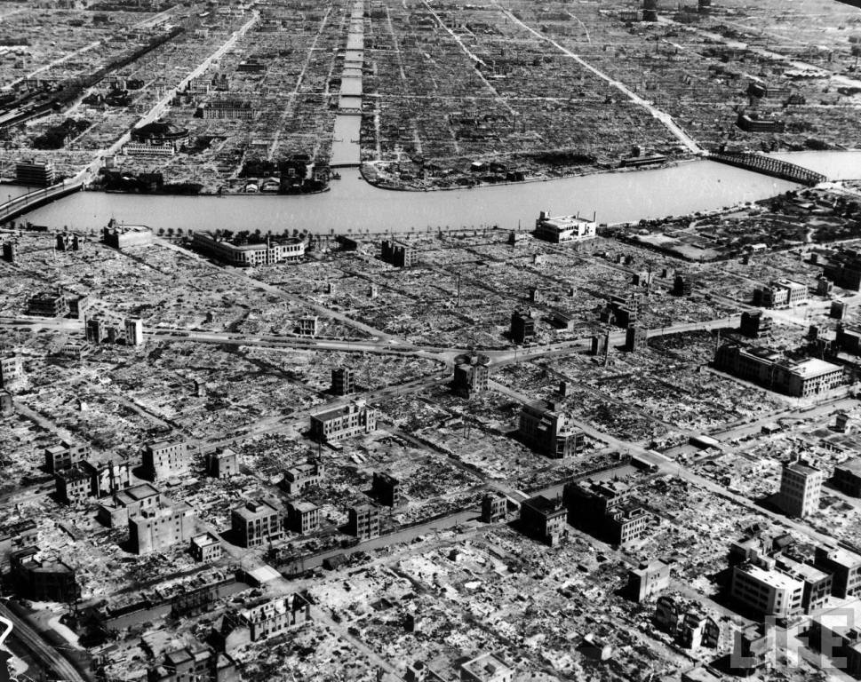
THE USE OF THIS BOMB HAD NOTHING TO DO WITH PRESSURING JAPAN INTO SURRENDER. THE REAL REASON FOR DROPPING THOSE BOMBS CAME FROM PRESIDENT TRUMAN'S FRUSTRATION WITH STALIN AFTER THE YALTA CONFERENCE. ACCORDING TO TRUMAN, STALIN HAD MADE A COMMITMENT IN FEBRUARY 1945 IN YALTA TO ALLOW THE COUNTRIES OF EASTERN EUROPE FREE ELECTIONS. STALIN DIDN'T HONOR that COMMITMENT, AND WHEN TRUMAN MET WITH STALIN IN POSTDAM IN JULY 1945, TRUMAN HINTED THAT HE HAD A new WEAPON. IS IT COINCIDENCE THAT THE BOMB WAS DROPPED A WEEK LATER? WAS TRUMAN ONLY TRYING TO INTIMIDATE STALIN? IT CERTAINLY SEEMS SO, AND IF IT THAT'S TRUE, THEN THE USE OF THE ATOMIC BOMB ON THE JAPANESE IS WORSE THAN UNJUSTIFIABLE - IT IS Reprehensible.
3.2.9 Describe the tragedy of war with reference to each:
The Holocaust
Allied bombing of Dresden
Japanese treatment of prisoners of war

3.3 The student will be expected to draw upon primary and/or secondary sources to demonstrate an understanding of wartime conferences and political developments which helped shape the postwar period.

3.3.1 Define:
Atlantic Charter: In 1941 U.S. President Roosevelt and British Prime Minister Winston Churchill announced the Atlantic Charter, which set forth Allied goals for World War II and the postwar period. The two nations pledged to respect “the right of all peoples to choose the form of government under which they will live” and promised a free world without war, after the final destruction of Nazi tyranny.
Sphere-of-influence: Refers to a major power’s domination over a geographic area.
Nuremberg Trials: Public trials of former Nazi leaders at the end of World War II. The charges included waging aggressive war and crimes against humanity.

3.3.2 Describe the general agreements made at Yalta regarding the political future of Germany and Eastern Europe with reference to:
the division of Germany
free elections in Eastern Europe
Almost from the beginning of World War II the Allied leaders, Roosevelt, Churchill and Stalin met to plan strategy and discuss post war policy.

Yalta: At Yalta in February, 1945 Churchill, Roosevelt & Stalin agreed that Germany would be temporarily be divided into three zones, with Britain, the United States and the Soviet Union each controlling a zone. The former German capital Berlin, deep in the Soviet zone, would also be divided into three zones. The key issue was the future of Eastern Europe, particularly Poland. Soviet troops occupied most of the region and Stalin was determined that the Eastern European countries of Poland Czechoslovakia, Hungary and Romania have pro-Soviet governments. He wanted control of these countries as a buffer zone to protect Russia from invasion. When Soviet troops freed Poland from Germany Stalin installed a pro Soviet government called Lublin Poles. Roosevelt and Churchill were reluctant to allow Poland to fall under Soviet control, Britain had entered WW II to guarantee Poland’s independence. When Germany conquered Poland, a government in exile was formed in London called the London Poles. Poland would be a test case for the future of all Eastern Europe. American and British recognition of Soviet control would signal Stalin’s right to establish a sphere of influence in all Eastern Europe. At the insistence of Roosevelt and Churchill, Stalin pledged that free elections would be held in Eastern European countries as soon as possible. However Stalin left Yalta believing Soviet domination in Eastern Europe would not be challenged.

3.3.3 Draw conclusions about how differing interpretations of the Yalta agreements between the Soviet Union and the West might pose future tension over Germany and Eastern Europe.
3.3.4 Analyze the decisions reached at Potsdam regarding contentious issues relating to Poland and Germany.

Potsdam: Between July 17 & August 17 1945 the last wartime conference was held at Potsdam. Stalin met with U.S. President Harry Truman (Roosevelt had died) and British Prime Minister Clement Atlee (Churchill lost election). Like Yalta there were agreements and disagreements. It was agreed that all Nazi institutions would be dismantled and Nazi war criminals would be tried and punished. Reparations would be paid in machinery, the Soviets had the right to take what they wanted from the Eastern sector and 35% from the western sector. They could not agree on the future of Germany so the “temporary arrangement” to divide Germany and Berlin remained in effect. There was disagreement on the question of Poland. The West wanted to reinstate the London Poles while Stalin would only recognize the Lublin Poles who were already in place. The western powers finally backed down and accepted Soviet control of Poland. The disagreements at Yalta and Potsdam provided a glimpse into the Cold War to come. The American/West view was that Soviet control of Eastern Europe was temporary. The Soviet view was that Eastern Europe was now in its sphere of influence.

3.3.5 Evaluate how new leaders and technological developments increased tension at Potsdam.
President Truman saw things in black and white terms, with little room for compromise. As a result he adopted a “get tough” attitude with the Soviets. He believed the Soviets were acting like a bully in Europe and should be made to mend its ways. Unlike Roosevelt, Truman was highly suspicious of the Soviets and had no intention of working closely with Stalin like Roosevelt. This new approach towards the Soviets increased tensions. In August 1945 the United states ended WWII by dropping atomic bombs on the Japanese cities of Hiroshima and Nagasaki.

The atomic bomb became a source of tension for several reasons:
1. Truman had not told Stalin that the U.S. intended to drop these on Japan.
2. The U.S. refused to share the secret of how to make such a bomb.
3. Stalin was convinced the U.S. would use the bomb to win worldwide power.
4. Stalin ordered his scientists to develop an atomic bomb.

The U.S. felt threatened by this.

3.3.6 Analyze the challenges faced by the United Nations with reference to its:
structure
purposes and principles
United Nations

One of the allies' goals during WWII was to create an international organization to ensure global collective security.
Thus the United Nations was created in October 1945.
Its purpose was to:
1. maintain international peace & settle disputes
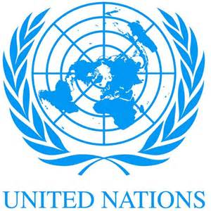
2. develop equal rights & national self determination
3. solve social, economic & humanitarian problems

Some of the basic principles of the United Nations were:
1. the equality of all members
2. all members fulfill its UN obligations
3. settle disputes peacefully
4. refrain the use of force against any state
5. help the UN in any action it undertakes

The League of Nations had been too weak to stop aggression because major powers were unwilling to give up their self-interest to such an international organization. President Roosevelt was determined to make the United Nations a strong organization by ensuring that all major powers be involved. To ensure American commitment the headquarters were put in the United States. The main problem was how to accommodate the national self-interest of large & small powers. What was needed was a formula that would give major powers a greater role in the United Nations while still recognizing the need of all countries to have a voice.

The solution was to divide the UN into two parts:
The General Assembly in which each country had one vote and the Security Council controlled by the major powers.

The structure of the United Nations presented some challenges:
General Assembly:
• All members met in the assembly to present their positions on issues.
• Each country has 1 vote, most decisions are reached by a simple majority.
• On questions of peace or expulsion of a member, a majority of 2/3's is required.
• Critics say the General Assembly is an ineffective “talk shop” where nations simply play politics.

Security Council:
The real power behind the UN is the Security Council, which is made up of 2 groups:
• Five permanent members: China, France, Britain, Russia and the United States. Permanent members have veto power which is the right to stop any UN action.
• Ten non-permanent members: elected for two year terms

The major responsibility of the Security Council is to maintain peace and security. It can order a ceasefire, impose economic sanctions and authorize the use of military force against an aggressor.

Critics point out that the veto power of the permanent members is a weakness
of the UN. They argue that countries will use the veto to block any UN action
that is not in their self-interest. During the Cold War the Security Council was
often deadlocked as the U.S. and Soviets often used the veto against each
other.

It must be pointed out that the veto power ensured the continuing commitment of all major powers and that there has been no large scale wars since its creation.

“Our instrument and our last hope is the United Nations, and I see little
merit in the impatience of those who would abandon this imperfect instrument
because they dislike our imperfect world.”
- John F. Kennedy, 1962-

“At the UN everybody wins a few, loses a few, settles for half a loaf. No one, not the U.S., not the USSR, not Japan, not China, not India can get away with playing the Big Bully or the Lone Ranger.”
-India’s Ambassador to the UN, 1985-

3.3.7 Use selected pieces of music, fashion, art or literature to show the impact of World War II on the daily lives of citizens.

