Literature Lab: Home Remedies
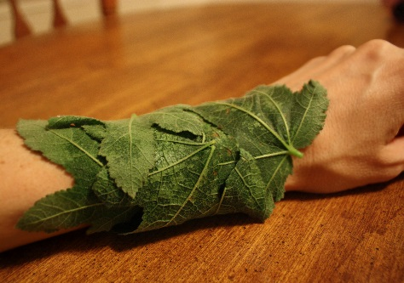

Describe your home remedy ________________________________________________________________________________________________________________________________________________________________________________________________________________________________________________________________________________________________________________________
Draw a picture of the remedy/ or the process of the remedy

Explain how this remedy might have been used during Elizabeth Goudies’ time
_______________________________________________________________________________________________________________________________________________________________________________________________________________________________________________________________________________________________________________________________________________

Is this remedy useful today? Why or why not? ______________________________________________________________________________________________________________________________________

