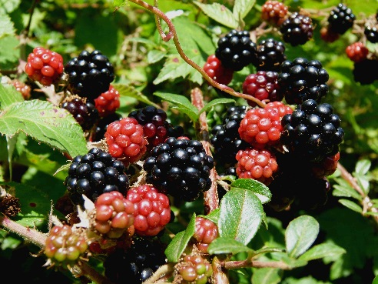
LABRADOR BERRY LIT.LAB
Group Members: ______________________________
______________________________
______________________________
______________________________

Name of your creation _____________________________________
List of ingredients, and person responsible for bringing items. Remember, things such as butter, milk, eggs, baking powder, sugar will be provided. Make a list to organize the group.

Provide your recipe here. Make sure you include exact measurements.

Reflection: How do you think your recipe could be useful to Elizabeth Goudie? Explain

