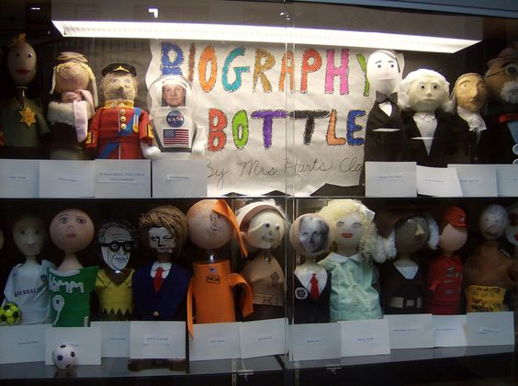
Bottle Biographies
History 3201
Unit 2 Assignment
Your task is to select one of the independence revolutionary leaders below and write a 3 page research paper about them, AND create a visual representation of the person (bottle bio).
- Joseph Stalin
- Benito Mussoili
- Adolf Hitler
- Leon Trotsky
-Alexander Kerensky
-Czar Nicholas II
-Empress Alexandria
-Vladimir Lenin

Written report: You will write a 2-3 page (typed and double spaced) research paper on the leader. This paper will be in MLA format (see guide on Weebly). The report must include a cover page, appropriate formatting and a “works cited” page documenting a minimum of 5 sources you consulted during research. Include 2-3 pictures embedded within the text and be sure to cite them, as well as provide a caption explaining the contents.
You must answer the following essential questions.
-Background information (birth place, upbringing, education, etc.)
-Historical/Political significance. Why is this person important? What historical events did they play a part in?
-What were their political objectives? Were they effective in achieving their objectives? Why or why not?
- What is their legacy?
These questions may serve as headings if you wish, but this is a research paper and NOT simply question and answers. Use appropriate essay writing style for formal academic writing.

Bottle bio:
Make a bottle buddy using a 2-liter bottle for the body and a painted 4” Styrofoam ball or be creative and use something else for the head. Fill the bottom with 2 inches of sand or dirt. (Sand in the bottom will help them stand.) Bottle must be emptied and cleaned. To make your bottle like your person use any material available: felt, paint, fabric, rocks, sticks, hats, construction paper, aluminum foil, etc. to create their costume and props. Have fun and be creative.

Citing your material MLA:
In-text Citations:
All work must be cited, whether it is quoted or paraphrased for anything that is not your own. Facts of general knowledge (such as mammals drink milk or the capital of Canada is Ottawa) do not need parenthetical citations because they are basic facts. When citing material within a paragraph make sure you place parenthetical citations at the end of the sentence you are utilizing either a paraphrase and/or quote.
Use of Authors’ Names: You must always mention authors’ names when taking material from their works. You may either do this in the text itself or in the parenthetical citation.
eg. (Whitehouse, 2012)
If no author is identified: When a source does not include an author’s name, use the title in the parenthetical citation. Underline the title if the source is a book; use quotation marks is it if an article:
eg. (“Making CRM Work,” 2012).

Works Cited:
A separate alphabetical list of all the sources you used for your research project. It appears at the end and must follow a particular pattern.
Works Cited- the title of the page- centered
Documenting Article or Page on a Website:
Author(s). “Title of Article or Page.” Name of Web Site. Date of last update or revision. Name of sponsoring institution or organization. Date of Access. <electronic address or URL>.
• Mabillard, Amanda. "Shakespeare of Stratford." Shakespeare Online. 4 April 2002. 13 May 2002. <http://www.shakespeare-online.com>.
• “Ranch-Raised Fur: Captive Cruelty.” PETA Factsheets. People for the Ethical Treatment of Animals (PETA). 13 May 2002. <http://www.peta-online.org/ mc/facts/fswild3.html>.

